

ASSET VERIFICATION AND RECORDING TOOL KIT


Plot 31, Bukoto Street
P.O Box 7657, Kampala, Uganda
+256 (0) 39 2000216/0772525235
email: cpa@cpa.ug

www.cpa.com

August to September 2026

VERIFICATION DETAILS

NAME OF THE REGION: | WESTERN REGION
SUB-REGION: | TOORO/ RWENZORI
Name of Local Government | FORT PORTAL CITY
VERIFIER PARTICULARS
Full name | KATO CHARLES
Contact/ email and Telephone | 0755790124 katoc560@gmail.com
Supervisor/ Sub team leader
Name | DEPAUL MBONIGABA
Contact | 0788483159
Date of submission | 24/08/2026

HEALTH CENTRES
INFORMANT INTERVIEW/DISCUSSION GUIDE (INCHARGE OR RESPONSIBLE PERSON)

Name of Health Centre: RUBINGO HC III

1a | Does the Facility have a record of all assets provided under UgIFT.  (Obtain a record and verify if it has the costs and numbers supplied
1b | If Not ask how many were supplied and when. | The list did not have numbers

2 | How does this facility Maintain (repair/service/replace) the assets provided under Ugift

Minor repairs are done using available PHC funds however it’s inadequate
to facilitate major maintenance.

3 | Does the facility take regular record about functionality/ or breakdown of the assets provided? | Yes
A list of assets received by the facility was available, however some equipment were not yet assembled and other pilled in the store

4 | How has the UgIFT support helped in service delivery in the area, any issues, challenges and any recommendations for better program implementation.
UGIFT program improved health workers’ welfare in terms of housing and comfortability while working and the overall sanitation at the facility. Similarly, the facility faced some challenges in that some assets were not assembled and are still in their boxes from the time of delivery.
The facility, also facility in charge, was also frustrated by the delays in addressing the above challenge.
The incharge recommended that assembling of medical equipment should be done before issuance of project completion certificate.

PROCEED TO VERIFICATION AFTER THIS DISCUSSION

Health centre checklist

NAME OF LG: FORT PORTAL CITY COUNCIL NAME OF HEALTH FACILITY: RUBINGO HC III

Equipment/ Item | Department | Asset Number | Item  Description | Life in Months | Tag Number ( engrave no.) | Date Of Purchase | Date Placed In Service | Recoverable cost | Cost | Acc Dep Cost | Net Book Value | Ytd Deprn | Equipment status | Remarks
B.P. Machine, Digital | Health |  | 1 automatic upper arm BP machine |  | Not engraved |  | 18/03/2024 |  |  |  |  |  | functional
 | Health |  | 1 automatic upper arm BP machine |  | Not engraved |  | 18/03/2024 |  |  |  |  |  | functional
B.P. Machine (Aneroid wall mounted) | HEALTH |  | 1 BP machine however not mounted | Not indicate on the machines | Not engraved |  | 18/03/2024 |  |  |  |  |  | Not functional | Asset register not available, and equipment not mounted
 | HEALTH |  | 1 BP machine however not mounted | Not indicate on the machines | Not engraved |  | 18/03/2024 |  |  |  |  |  | Not functional | Asset register not available, and equipment not mounted
Autoclave 20 Litres. Duo Operated | HEALTH |  | 1 Steel auto clave with metallic lead and pressure valves | Could not be determined | Not engraved |  | 18/03/2024 |  |  |  |  |  | functional
Bowl, Kick | HEALTH |  | 1 bowl, kick | Could not be determined | Not engraved |  | 18/03/2024 |  |  |  |  |  | Not functional | Item in the store
 | Health |  | 1 bowl, kick |  | Not engraved |  | 18/03/2024 |  |  |  |  |  | Functional
Bowl Stand | Health |  | 1 stainless movable bowl stand |  | Not engraved |  | 18/03/2024 |  |  |  |  |  | Functional
 | Health |  | 1 stainless movable bowl stand |  | Not engraved |  | 18/03/2024 |  |  |  |  |  | Functional
 | Health |  | 1 stainless movable bowl stand |  | Not engraved |  | 18/03/2024 |  |  |  |  |  | Functional
Counting chamber Neubauer- Improved | health |  | 1 improved Neubauer of 0.0025mm² counting chambers | Not indicated | Not engraved |  |  |  |  |  |  |  | Not functional | The lab personnel suggested that they should be given a CBC machine instead
 | health |  | 1 improved Neubauer of 0.0025mm² counting chambers | Not indicated | Not engraved |  |  |  |  |  |  |  | Not functional
 | health |  | 1 improved Neubauer of 0.0025mm² counting chambers | Not indicated | Not engraved |  |  |  |  |  |  |  | Not functional
Cupboard Steel, Lockable | Health |  | 1 grey lockable cabinet | Not indicated | Not engraved |  |  |  | 2,300,000 |  |  |  | Functional, though  wasn’t properly assembled though in use | The supplier did not leave copies of keys to the cup, and they were not assembled properly thus need repair
 | Health |  | 1 grey lockable cabinet | Not indicated | Not engraved |  |  |  | 2,300,000 |  |  |  | Functional, though  wasn’t properly assembled though in use
 | Health |  | 1 grey lockable cabinet | Not indicated | Not engraved |  |  |  |  |  |  |  | Functional
Drip Stand
ESR Stand
Examination Couch | health |  | 1 black metallic couch with mattresses | Not indicated | Not engraved |  |  |  |  |  |  |  | Functional
 | health |  | 1 black metallic couch with mattresses | Not indicated | Not engraved |  |  |  |  |  |  |  | Functional
Examination light, LED | Health |  | 1 led examination white in colour, movable | Not indicated | Not engraved |  |  |  |  |  |  |  | functional
 | Health |  | 1 led examination white in colour, movable | Not indicated | Not engraved |  |  |  |  |  |  |  | functional
Glucometer | health |  | 1 Yuwell type, complete set, SN: B2507000061, white in colour glucometer |  | Not engraved |  | 18/03/2024 |  |  |  |  |  | Not functional | The facility used up all strips, could not afford the replacement, cost and they are not available on the NMS credit line
 | health |  | 1 Yuwell type, complete set, SN: B2507000061, white in colour glucometer |  | Not engraved |  | 18/03/2024 |  |  |  |  |  | Not functional
 | health |  | 1 Yuwell type, complete set, SN: B2507000061, white in colour glucometer |  | Not engraved |  | 18/03/2024 |  |  |  |  |  | Not functional
Haemoglobin Meter, Digital | health |  | 1 black in colour haemoglobin meters, best for schools |  | Not engraved |  | 18/03/2024 |  |  |  |  |  | Not functional | The equipment is fit for school use, as said by the lap technician
 | health |  | 1 black in colour haemoglobin meters, best for schools |  | Not engraved |  | 18/03/2024 |  |  |  |  |  | Not functional
Height Meter | Health |  | 1 height meter with a stepping pallet |  | Not engraved |  | 18/03/2024 |  |  |  |  |  | functional
Instrument Trolley | Health |  | 1 stainless steel, movable trolly |  | Not engraved |  | 18/03/2024 |  |  |  |  |  | Functional
 | Health |  | 1 stainless steel, movable trolly |  | Not engraved |  | 18/03/2024 |  |  |  |  |  | Functional
Microscope Binocular | health |  | I microscope, with three lenses, white in colour | Not indicated | Not engraved |  | 18/03/2024 |  |  |  |  |  | Functional
Otoscope | Health |  | 1 otoscope |  | Not engraved |  | 18/03/2024 |  |  |  |  |  | Not functional
Patient Screen | Health |  | 1 patient screen, stainless, Folding screen  Sn: KL-H054 |  | Not engraved |  | 20,09/2025 |  |  |  |  |  | Functional | 4 screens were received by the facility
 | Health |  | 1 patient screen, stainless, Folding screen  Sn: KL-H054 |  | Not engraved |  | 20,09/2025 |  |  |  |  |  | Functional | 4 screens were received by the facility
 | Health |  | 1 patient screen, stainless, Folding screen  Sn: KL-H054 |  | Not engraved |  | 20,09/2025 |  |  |  |  |  | Functional | 4 screens were received by the facility
 | Health |  | 1 patient screen, stainless, Folding screen  Sn: KL-H054 |  | Not engraved |  | 20,09/2025 |  |  |  |  |  | Functional | 4 screens were received by the facility
Patient Trolley | Health |  | 1 patient trolley of casp |  |  |  | 20/9/2025 |  |  |  |  |  | functional
Refrigerator, Basic | Health |  | 1 refrigerator basic, Hisense brand | 18 months | Not engraved |  | 20/09/2025 |  |  |  |  |  | Not functional | Item still in the store
Stethoscope | Health |  | stethoscope |  | Not engraved |  | 20/9/2025 |  |  |  |  |  | Functional
 | Health |  | stethoscope |  | Not engraved |  | 20/9/2025 |  |  |  |  |  | Not functional | Items are still in the cupboard instrument
 | Health |  | stethoscope |  | Not engraved |  | 20/9/2025 |  |  |  |  |  | Not functional | Items are still in the cupboard instrument
 | Health |  | stethoscope |  | Not engraved |  | 20/9/2025 |  |  |  |  |  | Not functional | Items are still in the cupboard instrument
Stopwatch |  |  |  |  |  |  |  |  |  |  |  |  |  | Items are still in the cupboard instrument
Stretcher
 | Health |  | 1 stretcher, movable |  | Not engraved |  | 20/9/2025 |  |  |  |  |  | Not functional
Stove, Gas | health | HU-102 | STOVE GAS |  | Not engraved |  | 25/05/2023 |  | 592,400 |  |  |  | Not Functional
Weighing Scale with Height Meter, Adult | health |  | 1 weighing scale with height measure |  | Not engraved |  | 20/09/2025 |  |  |  |  |  | Functional
 | Health |  | 1 weighing scale with height measure |  | Not engraved |  | 25/03/2023 |  |  |  |  |  | functional
Weighing Scale, Infant | Health |  | 1 Hanging weighing scale for infants |  | Not engraved |  | 20/9/2025 |  |  |  |  |  | functional
 | Health |  | 1 Hanging weighing scale for infants |  | NOT ENGRAVED |  | 20/9/25 |  |  |  |  |  | FUNCTIONAL
Weighing Scale, Toddler | Health |  | 1 weighing scale toddler, KUANYI MODEL, BS-50 |  | Not engraved |  | 20/09/2025 |  |  |  |  |  | Not Functional
 | Health |  | 1 weighing scale toddler, KUANYI MODEL, BS-50 |  | Not engraved |  | 20/09/2025 |  |  |  |  |  | Functional
Wheelchair | Health |  | 1 wheelchair with drip stand |  | Not engraved |  | 20/09/2025 |  | 750,000 |  |  |  | Functional
 | Health |  | 1 wheelchair with drip stand |  | Not engraved |  | 20/09/2025 |  | 750,000 |  |  |  | Functional
Audio Visual Equipment | Health
Medical Waste Bin | health
 | Health |  | Stainless steel bins |  | Not engraved |  | 20/09/2025 |  |  |  |  |  | Functional
 | Health |  | Stainless steel bins |  | Not engraved |  | 20/09/2025 |  |  |  |  |  | Functional
 | Health |  | Medical waste bins |  | Not engraved |  | 20/09/2025 |  |  |  |  |  | Functional
Wall Clock
 | Health |  | Wall clock |  | Not engraved |  | 20/9/2025 |  | 300,000 |  |  |  | functional
 | Health |  | Wall clock |  | Not engraved |  | 20/9/2025 |  | 300,000 |  |  |  | functional
 | Health |  | Wall clock |  | Not engraved |  | 20/9/2025 |  | 300,000 |  |  |  | Functional
Diagnostic Equipment Set for MCH | Health | SL304 | Full diagnostic set consisting of all equipment (full medical package) |  | Not engraved |  | 23/06/2023 |  |  |  |  |  | Not functional
 | Health | SL304 | Full diagnostic set consisting of all equipment (full medical package) |  | NOT ENGRAVED |  | 24/09/2025 |  |  |  |  |  | NOT FUNCTIONAL
 | Health | SL304 | Full diagnostic set consisting of all equipment (full medical package) |  | NOT ENGRAVED |  | 24/09/2025 |  |  |  |  |  | NOT FUNCTIONAL
Diagnostic Equipment Set for OPD | Health | SL304
 | Health | SL304 | 1 diagnostic equipment set |  | Not engraved |  | 24/09/2025 |  |  |  |  |  | Not functional
 | Health | SL304 | 1 diagnostic equipment set |  | Not engraved |  | 24/09/2025 |  |  |  |  |  | Not functional
Glassware Set, Laboratory, Basic | Health |  | 1 glass ware set` |  | Not engraved |  | 24/09/2025 |  |  |  |  |  | Functional
 | Health |  | 1 glass ware set` |  | Not engraved |  | 24/09/2025 |  |  |  |  |  | Functional
Hollow Ware Set, Treatment | Health |  | 1 hollow ware set, full set |  | Not engraved |  | 24/09/2025 |  |  |  |  |  | Not functional
 | Health | SL304 | 1 hollow ware set, full set |  | Not engraved |  | 24/09/2025 |  |  |  |  |  | Not functional
Instrument Set, Dressing | Health | SL304 | 1 Set consists of forceps, scissors, bowls, lotion, kidney, instrument container s/s with cover |  | Not engraved |  | 24 |  |  |  |  |  | Not functional
 | Health | SL304 | 1 Set consists of forceps, scissors, bowls, lotion, kidney, instrument container s/s with cover. |  | Not engraved |  | 24/09/2025 |  |  |  |  |  | Functional
Instrument Set, Basic ENT | Health | SL304 | 1 Set consists of forceps, scissors, bowls, lotion, kidney, instrument container s/s with cover. |  | Not engraved |  | 24/09/2025 |  |  |  |  |  | Functional
Instrument Set, Suture | Health | SL304 | 1 Set consists of forceps, scissors, bowls, lotion, kidney, instrument container s/s with cover. |  | Not engraved |  | 24/09/2025 |  |  |  |  |  | Functional
Pulse Oximeter, Handheld | Health
 | Health |  | 1 Pulse oximeter, handheld |  | Not engraved |  | 20/09/2025 |  |  |  |  |  | Functional
 | Health |  | 1 Pulse oximeter, handheld |  | Not engraved |  | 20/09/2025 |  |  |  |  |  | Not functional
Bed, Adult Patient with Mattress | Health |  | Adult beds with metallic mattresses, model B11 batch no 20220542 |  | Not engraved |  | 20/9/2025 |  |  |  |  |  | functional
 | Health |  | Adult beds with metallic mattresses, model B11 batch no 20220542 |  | Not engraved |  | 20/9/2025 |  |  |  |  |  | Functional
 | Health |  | Adult beds with metallic mattresses, model B11 batch no 20220542 |  | Not engraved |  | 20/09/2025 |  |  |  |  |  | Functional
 | Health |  | Adult beds with metallic mattresses, model B11 batch no 20220542 |  |  |  | 20/09/2025 |  |  |  |  |  | Functional
 | Health |  | Adult beds with metallic mattresses, model B11 batch no 20220542 |  | Not engraved |  | 20/09/2025 |  |  |  |  |  | Functional
 | Health |  | Adult beds with metallic mattresses, model B11 batch no 20220542 |  | Not engraved |  | 20/09/2025 |  |  |  |  |  | Functional
 | Health |  | Adult beds with metallic mattresses, model B11 batch no 20220542 |  | Not engraved |  | 20/09/2025 |  |  |  |  |  | Functional
 | Health |  | Adult beds with metallic mattresses, model B11 batch no 20220542 |  | Not engraved |  | 20/09/2025 |  |  |  |  |  | Functional
 | Health |  | Adult beds with metallic mattresses, model B11 batch no 20220542 |  | Not engraved |  | 20/09/2025 |  |  |  |  |  | Functional
 | Health |  | Adult beds with metallic mattresses, model B11 batch no 20220542 |  | Not engraved |  | 20/09/2025 |  |  |  |  |  | Functional
Bed, Pediatric Patient, With Mattress | Health |  | pediatrics beds with mattresses metallic |  | Not engraved |  |  |  |  |  |  |  | Functional
 | Health |  | Pediatric beds with metallic mattresses |  | Not engraved |  | 20/9/2025 |  |  |  |  |  | Functional
 | Health |  | pediatrics beds with mattresses metallic |  | Not engraved |  | 20/9/2025 |  |  |  |  |  | Functional
 | Health |  | pediatrics beds with mattresses metallic |  | Not engraved |  | 20/9/2025 |  |  |  |  |  | Functional
 | Health |  | pediatric beds with mattresses metallic |  | Not engraved |  | 20/9/2025 |  |  |  |  |  | Functional
 | Health |  | Pediatric beds with metallic mattresses |  | Not engraved |  | 20/9/2025 |  |  |  |  |  | Functional
Bedside Locker |  |  |  |  |  |  |  |  |  |  |  |  |  | Facility did not receive these items
Cupboard, Instrument
 |  |  | 1 cupboard steel lockable |  | Not engraved |  | 20/9/2025 |  |  |  |  |  | functional
Delivery Bed, Hydraulic Manual | health |  | 1 Delivery bed manual hydraulic |  | Not engraved |  | 6/9/2023 |  |  |  |  |  | Functional
Oxygen Therapy Apparatus, Minimum 45L cylinder | Health |  | 1 Oxygen cylinder of 49,8L 2, oxygen regulators (2), humidifier bottles (2) |  | Not engraved |  | 24/09/2025 |  |  |  |  |  | Not functional
 |  |  | 1 Oxygen cylinder of 49,8L 2, oxygen regulators (2), humidifier bottles (2) |  | Not engraved |  | 24/09/2025 |  |  |  |  |  | Not functional
Resuscitator Manual, Infant, with all Mask sizes | Health |  | 1 resuscitator manual |  | Not engraved |  | 24/09/2025 |  |  |  |  |  | Not functional
 | Health |  | 1 resuscitator manual |  | Not engraved |  | 24/09/2025 |  |  |  |  |  | Not functional
Resuscitator Manual, Adult, with all mask sizes | Health |  | 1 resuscitator manual, adult |  | Not engraved |  | 24/09/2025 |  |  |  |  |  | Not functional
 | Health |  | 1 resuscitator manual, adult |  | Not engraved |  | 24/09/2025 |  |  |  |  |  | Not functional
Suction Apparatus, (Electric)
 | Health |  | 1 suction apparatus, electric |  | Not engraved |  | 24/09/2025 |  |  |  |  |  | Not functional
Nebulizer, Ultrasonic
 | Health |  | 1 nebulizer ultrasonic |  | Not engraved |  | 24/09/2025 |  |  |  |  |  | Not functional
Oxygen Concentrator, Duo Flow
 | Health |  | 1 Oxygen concentrator |  | Not engraved |  | 20/09/2025 |  |  |  |  |  | functional
 | Health |  | 1 Oxygen concentrator |  | Not engraved |  | 20/09/2025 |  |  |  |  |  | functional
Bench
 | Health |  | 1 metallic vanished bench |  | GOU/MOH-UGIFT PROJECT  FY/2023/2024 |  | 16/04/2024 |  | 950,000 |  |  |  | functional
 | Health |  | 1 metallic vanished bench |  | GOU/MOH-UGIFT PROJECT  FY/2023/2024 |  | 16/04/2024 |  | 950,000 |  |  |  | functional
 | Health |  | 1 metallic vanished bench |  | GOU/MOH-UGIFT PROJECT  FY/2023/2024 |  | 16/04/2024 |  | 950,000 |  |  |  | functional
 | Health |  | 1 metallic vanished bench |  | GOU/MOH-UGIFT PROJECT  FY/2023/2024 |  | 16/04/2024 |  | 950,000 |  |  |  | functional
Disinfection Buckets
 | Health |  | 1 disinfection bucket 20L |  | Not engraved |  | 16/04/2024 |  | 83400 |  |  |  | functional
 | Health |  | 1 disinfection bucket |  | Not engraved |  | 16/04/2024 |  | 83400 |  |  |  | functional
 | Health |  | 1 disinfection bucket |  | Not engraved |  | 16/04/2024 |  | 83400 |  |  |  | functional
 | Health |  | 1 disinfection bucket |  | Not engraved |  | 16/04/2024 |  | 83400 |  |  |  | functional
 | Health |  | 1 disinfection bucket |  | Not engraved |  | 16/04/2024 |  | 83400 |  |  |  | functional
 | Health |  | 1 disinfection bucket |  | Not engraved |  | 16/04/2024 |  | 83400 |  |  |  | functional
Baby Cot
 | Health |  | 1 baby cot |  | Not engraved |  | 14/11/2025 |  |  |  |  |  | functional
 | Health |  | 1 baby cot |  | Not engraved |  | 14/11/2025 |  |  |  |  |  | functional
Diagnostic Equipment Set for Ward | Health
 | health |  | 1 Set consists of:  Depressor, tongue, metal, hammer, percussion, reflex test, solid rubber head, ophthalmoscope, aneroid cuffs, stethoscope, tape, measure, cloth, thermometers, tuning forks, proctoscope, and syringes |  | Not engraved |  | 24/09/2025 |  |  |  |  |  | Functional
Hollow Ware Set, Ward
 | Health |  | 1 hollow ware set consisting of a bed pan s/s with lid, bowl, urinal, lotions, forceps, instrument trays, jug measuring 1 litre, and kidney dishes |  | Not engraved |  | 14/11/2025 |  |  |  |  |  | Not functional | Iitem in the store
Instrument Set, Delivery | Health |  | 1 set consisting of forceps, sponge holding, needle holder, scissors, speculum, bowls, kidney dish, and instrument container |  | Not engraved |  | 14/11/2025 |  |  |  |  |  | functional
 | Health |  | 1 set consisting of forceps, sponge holding, needle holder, scissors, speculum, bowls, kidney dish, and instrument container |  | Not engraved |  | 14/11/2025 |  |  |  |  |  | functional
 | Health |  | 1 set consisting of forceps, sponge holding, needle holder, scissors, speculum, bowls, kidney dish, and instrument container |  | Not engraved |  | 14/11/2025 |  |  |  |  |  | functional
Instrument Set, Stitch Removing | Health
MVA Kit | Health |  | 1 MVA kit consisting of MVA Kit (double valve) forceps, sponge holding, manual valve aspirator, syringe aspirator 60CC, Karman cannulas with adaptor, speculum bowls, lotion |  | Not engraved |  | 18/03/2024 |  |  |  |  |  | functional
 | Health |  | 1 MVA kit consisting of MVA Kit (double valve) forceps, sponge holding, manual valve aspirator, syringe aspirator 60CC, Karman cannulas with adaptor, speculum bowls, lotion |  | Not engraved |  | 18/03/2024 |  |  |  |  |  | Not functional
 | Health |  | 1 MVA kit consisting of MVA Kit (double valve) forceps, sponge holding, manual valve aspirator, syringe aspirator 60CC, Karman cannulas with adaptor, speculum bowls, lotion |  | Not engraved |  | 18/03/2024 |  |  |  |  |  | Not functional
Stool, Laboratory | Health |  | 1 movable metallic stool |  | Not engraved |  | 24/09/2025 |  |  |  |  |  | functional
Penguin Sucker | Health
 | Health |  | 1 penguin |  | Not engraved |  | 18/03/2024 |  |  |  |  |  | Functional
 | Health |  | 1 penguin |  | Not engraved |  | 18/03/2024 |  |  |  |  |  | Functional
 | Health |  | 1 penguin |  | Not engraved |  | 18/03/2024 |  |  |  |  |  | Functional
Fetoscope, Doppler | Health |  | 1 fetoscope |  | Not engraved |  | 20/09/2025 |  |  |  |  |  | functional
 | Health |  | 1 fetoscope |  | Not engraved |  | 20/09/2025 |  |  |  |  |  | functional
Bubble CPAP | Health |  | 1 bubble CPAP |  | Not engraved |  | 20/09/2025 |  |  |  |  |  | Not functional
 | Health |  | 1 bubble CPAP |  | Not engraved |  | 20/09/2025 |  |  |  |  |  | Not functional
Centrifuge (Electric) | Health |  | 1 Centrifuge, new |  | Not engraved |  | 24/09/25 |  |  |  |  |  | Functional
 | Health |  | 1 Centrifuge, new |  | Not engraved |  | 24/09/2025 |  |  |  |  |  | Functional
Kangaroo Mother Care Chair | Health |  | 1 kangaroo mother care chair, brown colour |  | Not engraved |  | 24/09/2025 |  |  |  |  |  | Not functional
Radiant Infant Warmer | health |  | 1 radiant infant warmer |  | Not engraved |  | 20/09/2025 |  |  |  |  |  | functional
Haemoglobin Meter, Sahli | Health |  | 1 haemoglobin meter |  | Not engraved |  | 20/09/2025 |  |  |  |  |  | Not functional
 | Health |  | 1 haemoglobin meter |  | Not engraved |  | 24/09/2025 |  |  |  |  |  | Not functional
 | Health |  | 1 haemoglobin meter |  | Not engraved |  | 24/09/2025 |  |  |  |  |  | Not functional
Delivery Bed | Health |  | 1 Delivery bed |  | Not engraved |  | 20/09/2025 |  |  |  |  |  | Functional
 | Health |  | 1 Delivery bed |  | Not engraved |  | 20/09/2025 |  |  |  |  |  | Functional
Examination light | Health |  | 1 examination light |  | Not engraved |  | 20/09/2025 |  |  |  |  |  | functional
 | Health |  | 1 examination light |  | Not engraved |  | 20/09/2025 |  |  |  |  |  | functional
Instrument set, ENT Basic for HCIII | Health |  |  |  |  |  |  |  |  |  |  |  |  | These sets were not received by the facility, and they were marked with an Asterix
Bag Valve mask (Ambu Bag), Neonatal | Health |  | Bag valve mask, neonatal |  | Not engraved |  | 20/09/2025 |  |  |  |  |  | Functional | Number received by the facility could not be established as the incharge claimed to have many but no sure of the exact number
Incubator
Office Chair
 | health |  | Office chair, leather cushioned |  | Not engraved |  | 16/04/2024 |  | 700,000 |  |  |  | Functional
 | health |  | Office chair, leather cushioned |  | Not engraved |  | 16/04/2024 |  | 700,000 |  |  |  | Functional
 | health |  | Office chair, leather cushioned |  | Not engraved |  | 20/09/2025 |  | 700,000 |  |  |  | Functional
 | health |  | Office chair, leather cushioned |  | Not engraved |  | 20/09/2025 |  | 700,000 |  |  |  | Functional
 | health |  | Office chair, leather cushioned |  | Not engraved |  | 20/09/2025 |  | 700,000 |  |  |  | Functional
 | health |  | Office chair, leather cushioned |  | Not engraved |  | 20/09/2025 |  | 700,000 |  |  |  | Functional
Desk
 | Health |  | Table metallic frame of wooden top |  | GOU/MOH-UGIFT PROJECT  FY/2023/2024 |  | 16/04/2024 |  | Sh: 950000 |  |  |  | functional
 | Health |  | Table metallic frame of wooden top |  | GOU/MOH-UGIFT PROJECT  FY/2023/2024 |  | 16/04/2024 |  | Sh: 950000 |  |  |  | functional
 | Health |  | Table metallic frame of wooden top |  | GOU/MOH-UGIFT PROJECT  FY/2023/2024 |  | 16/04/2024 |  | Sh: 950000 |  |  |  | functional
 | Health |  | Table metallic frame of wooden top |  | GOU/MOH-UGIFT PROJECT  FY/2023/2024 |  | 20/09/2025 |  | Sh: 950000 |  |  |  | functional
 | Health |  | Table metallic frame of wooden top |  | GOU/MOH-UGIFT PROJECT  FY/2023/2024 |  | 20/09/2025 |  | Sh: 950000 |  |  |  | functional
 | Health |  | Table metallic frame of wooden top |  | GOU/MOH-UGIFT PROJECT  FY/2023/2024 |  | 20/09/2025 |  | Sh: 950000 |  |  |  | functional
Filing Cabinet |  |  |  |  |  |  |  |  |  |  |  |  |  | The facility recommended that it should be provided with more of these
 | Health |  | Filling cabinet |  | Not engraved |  | 20/9/2025 |  |  |  |  |  | Functional
 | Health |  | Filing cabinet |  | Not engraved |  | 20/9/2025 |  |  |  |  |  | functional
Non-Residential Buildings | Health |  | MATERNITY BUILDING with a placenta pit |  | Not engraved |  | 20/09/2025 |  |  |  |  |  | functional
 | Health |  | 1 six-stance lined pit latrine |  | Not engraved |  | 20/09/2025 |  |  |  |  |  | functional
 | Health |  | 1 fenced solar house with solar panels with Sn: 82400772, 82400080, 82400778,82400633 and batteries |  | Not engraved |  | 20/09/2025 |  |  |  |  |  | functional
Residential Buildings | Health |  | 1 staff house, 2 self-contained rooms with water 2 water tanks |  | Not engraved |  | 20/09/2025 |  |  |  |  |  | Functional

The table below illustrates some physical status of the verified assets with photographic evidence.
Table 1: Physical verification photos
RUBINGO SIGNPOST | 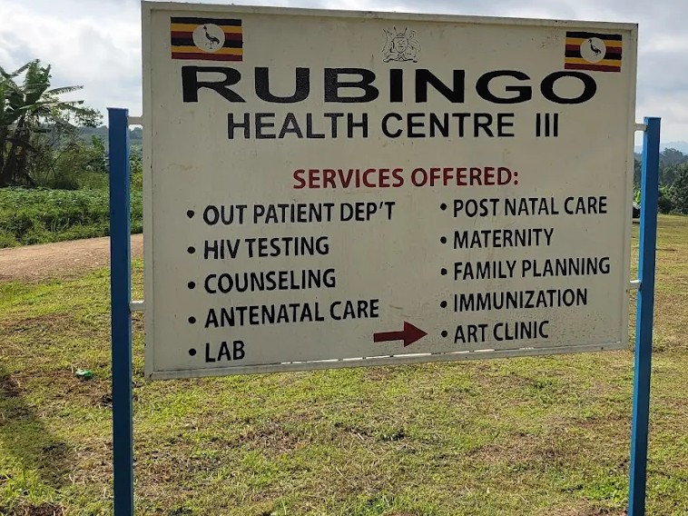
COMMISSIONING PLAQUE | THE BUILDING HAD NO COMISSIONING PLAQUE
TYPICAL SET OF STAFF QUARTER’S BLOCK  (HOUSE BLOCK WITH TWO UNITS, SELF CONTAINED WITH A 10000L WATER HAVESTING TANK) | 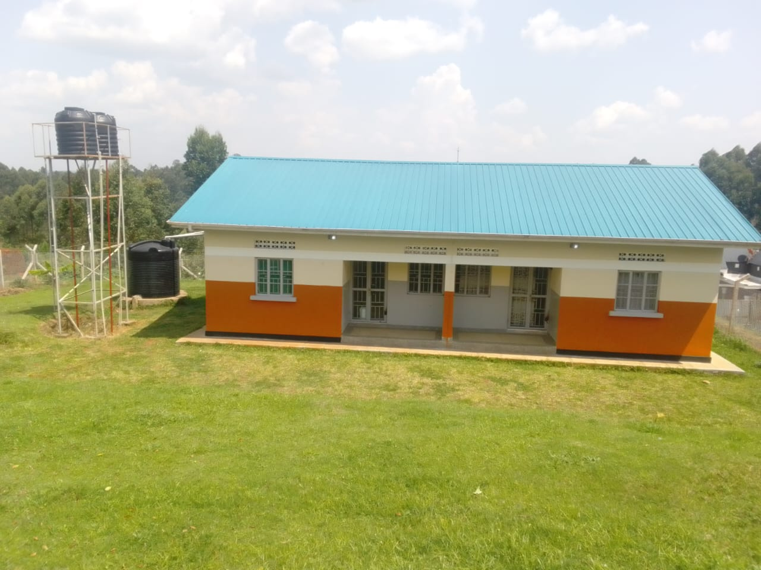
4 STANCE LINED PIT LATRINE | 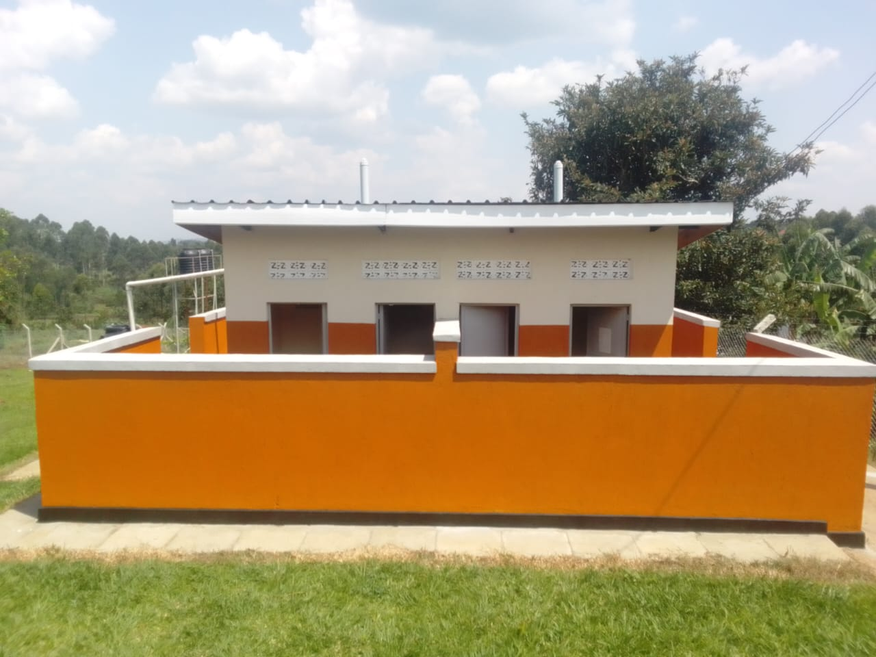
MATERNITY BUIL | 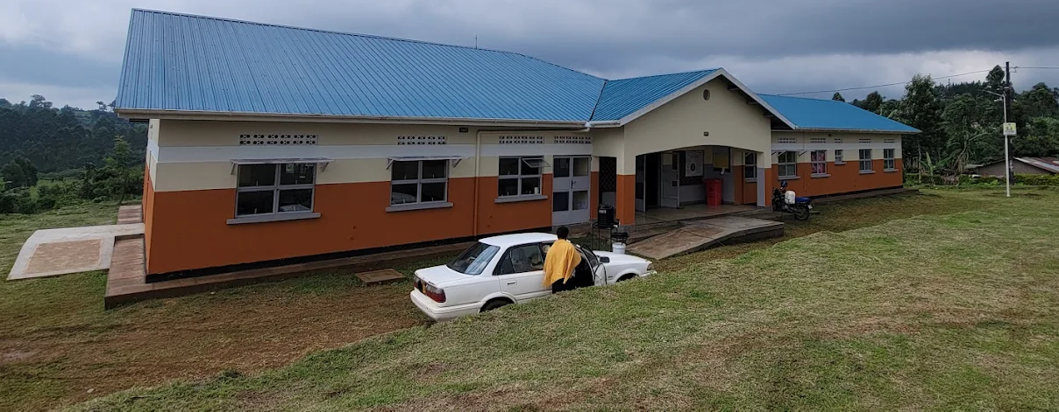
DING WITH A WASTE PIT AND A PLACENTA PIT | 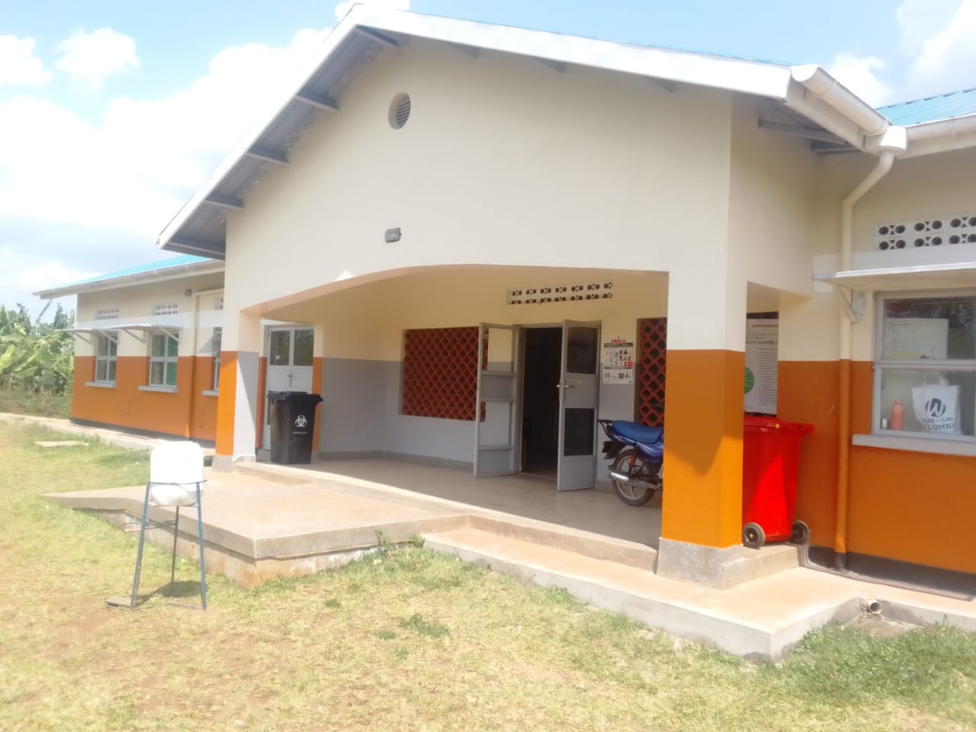
PACENTA PIT | 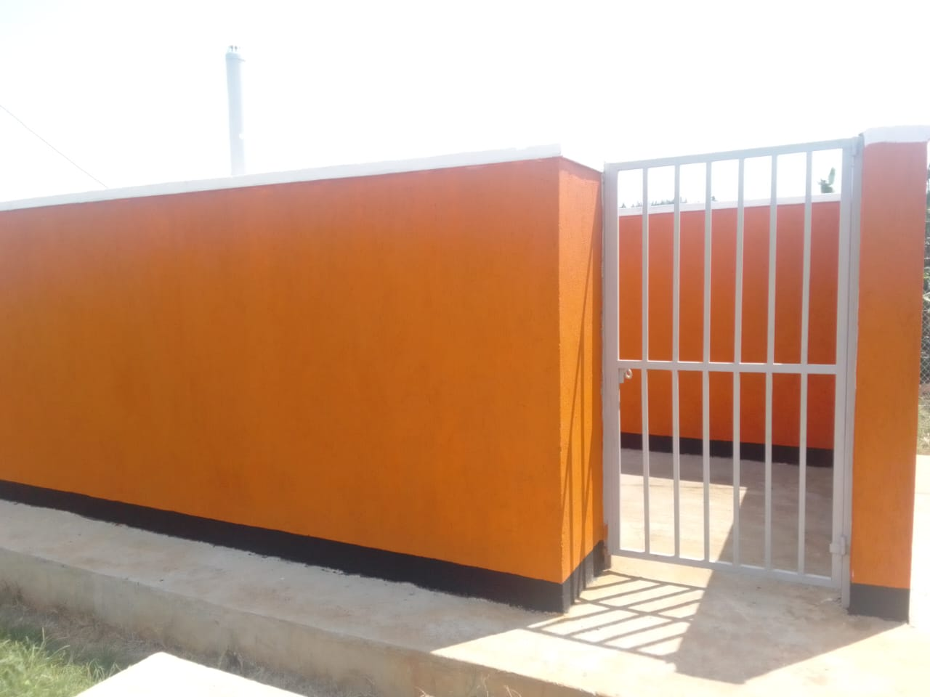
A FENCED SOLAR HOUSE, WITH BATTERIES | 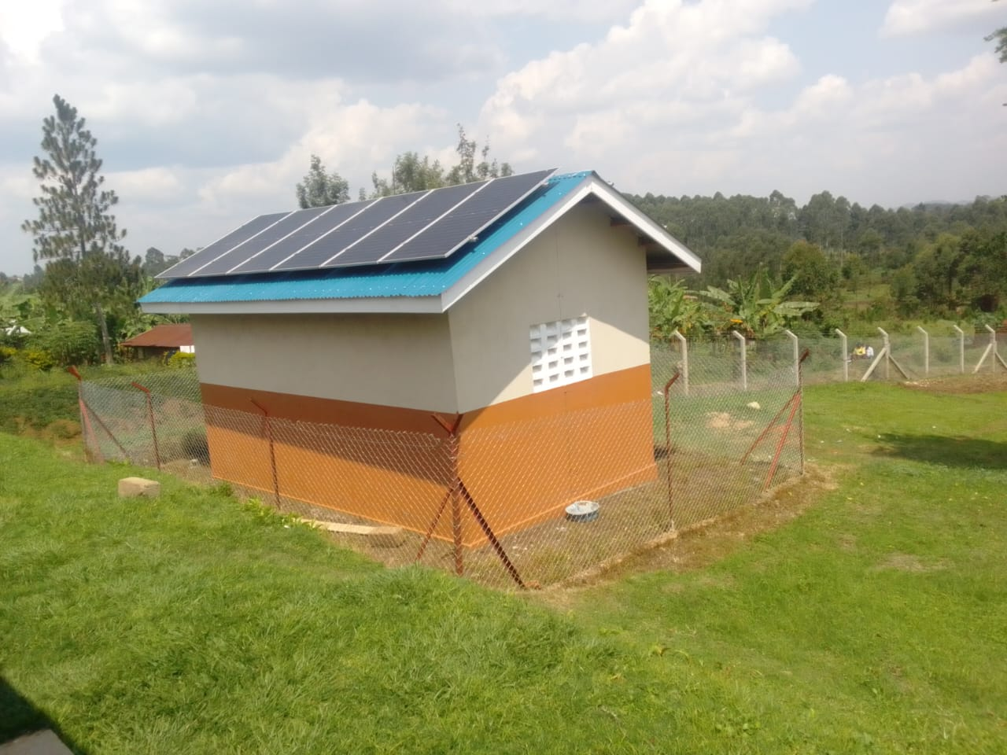
10,000LTRS HDPE CREST TANKS (3) WHICH FEEDS A 3,00OLTRS ELEVATED HDPE TANK WITH A PUMP | 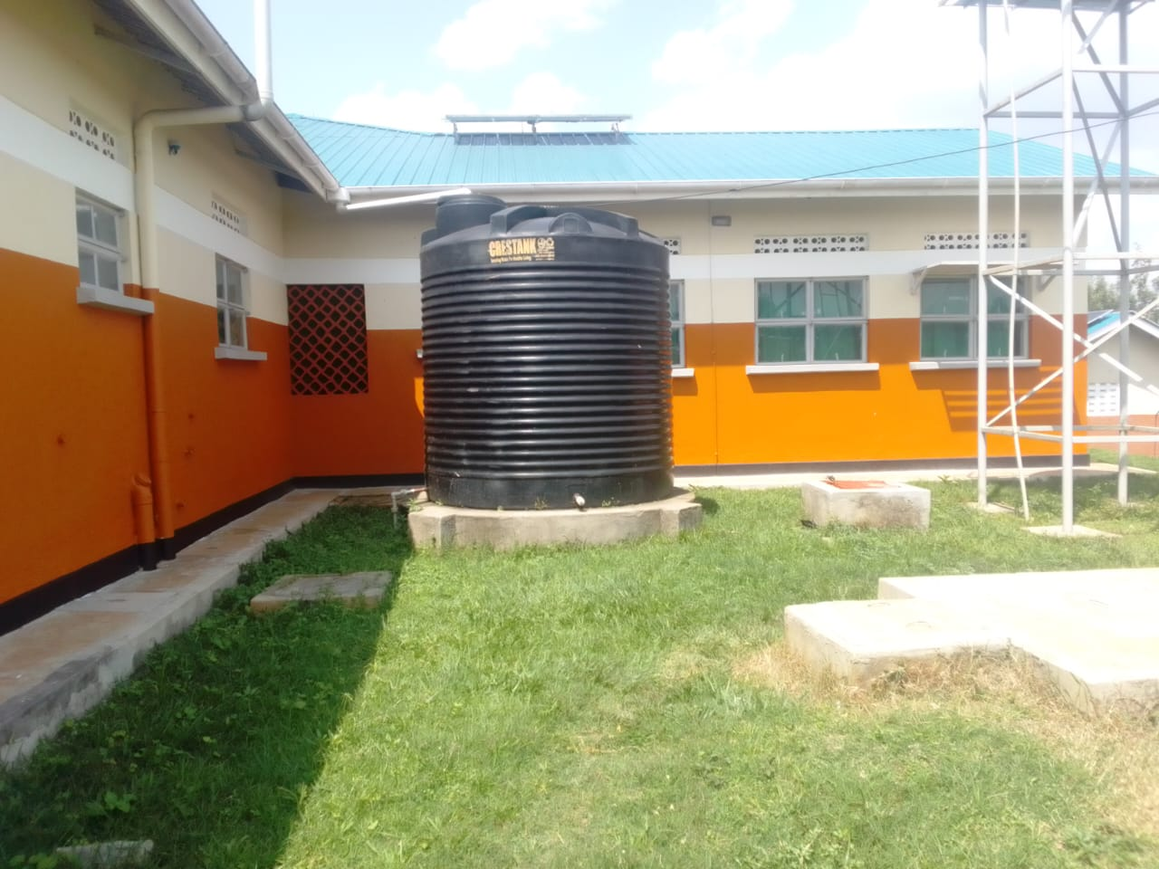
Refrigerator | 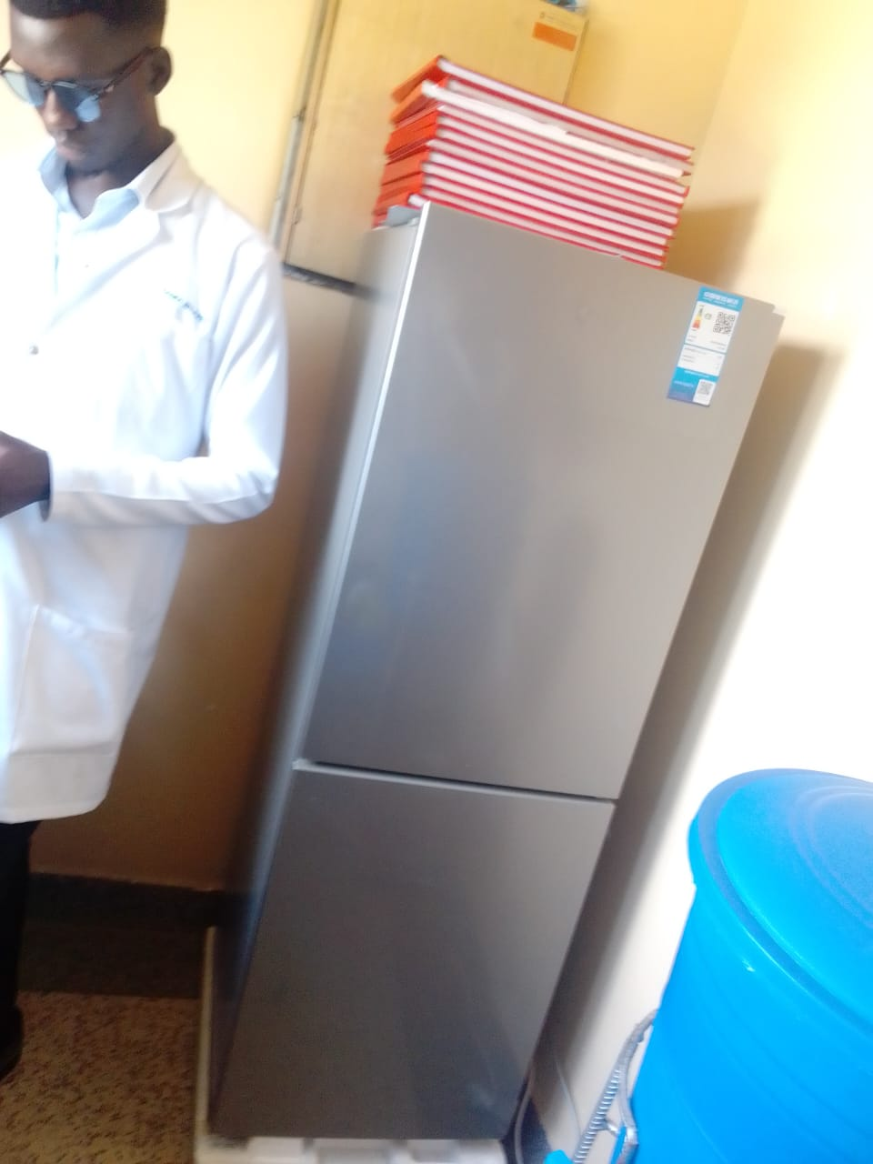
RADIANT INFANT WARMER | 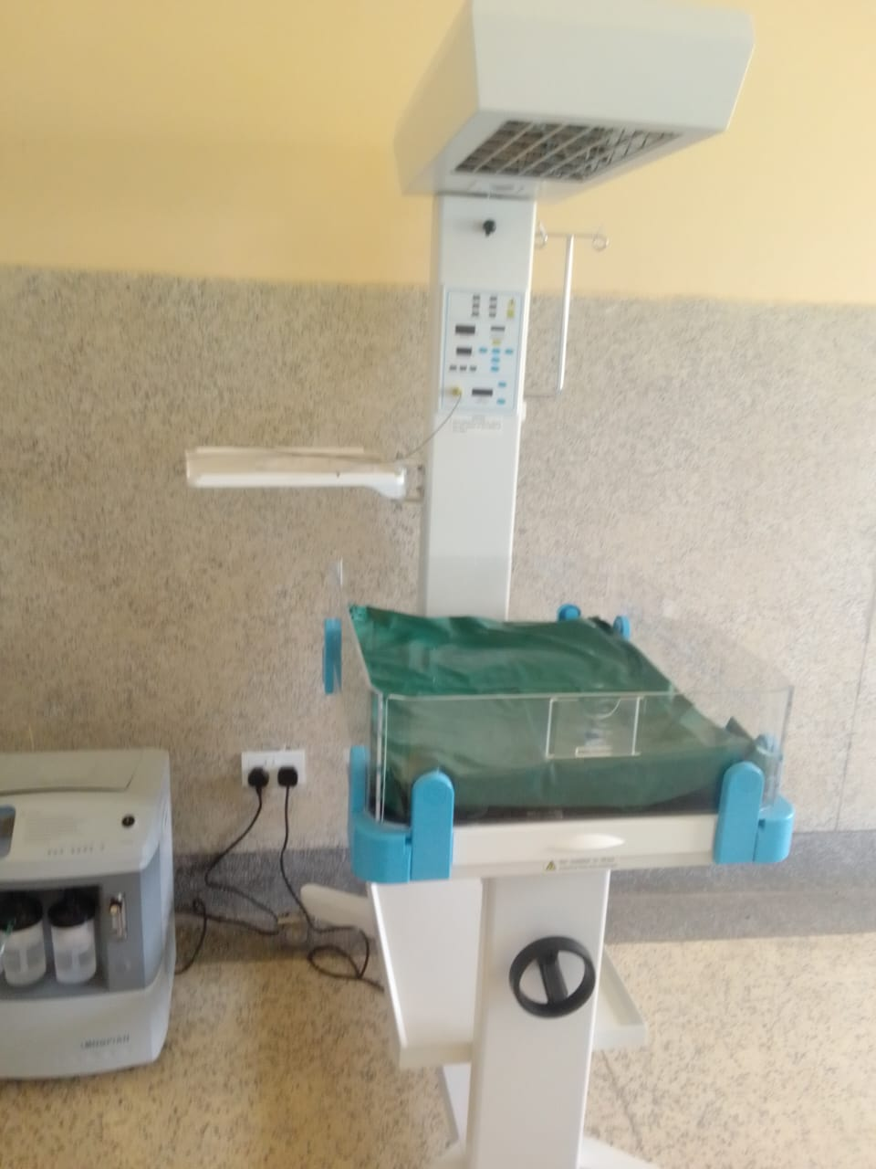
Disinfection bucket | 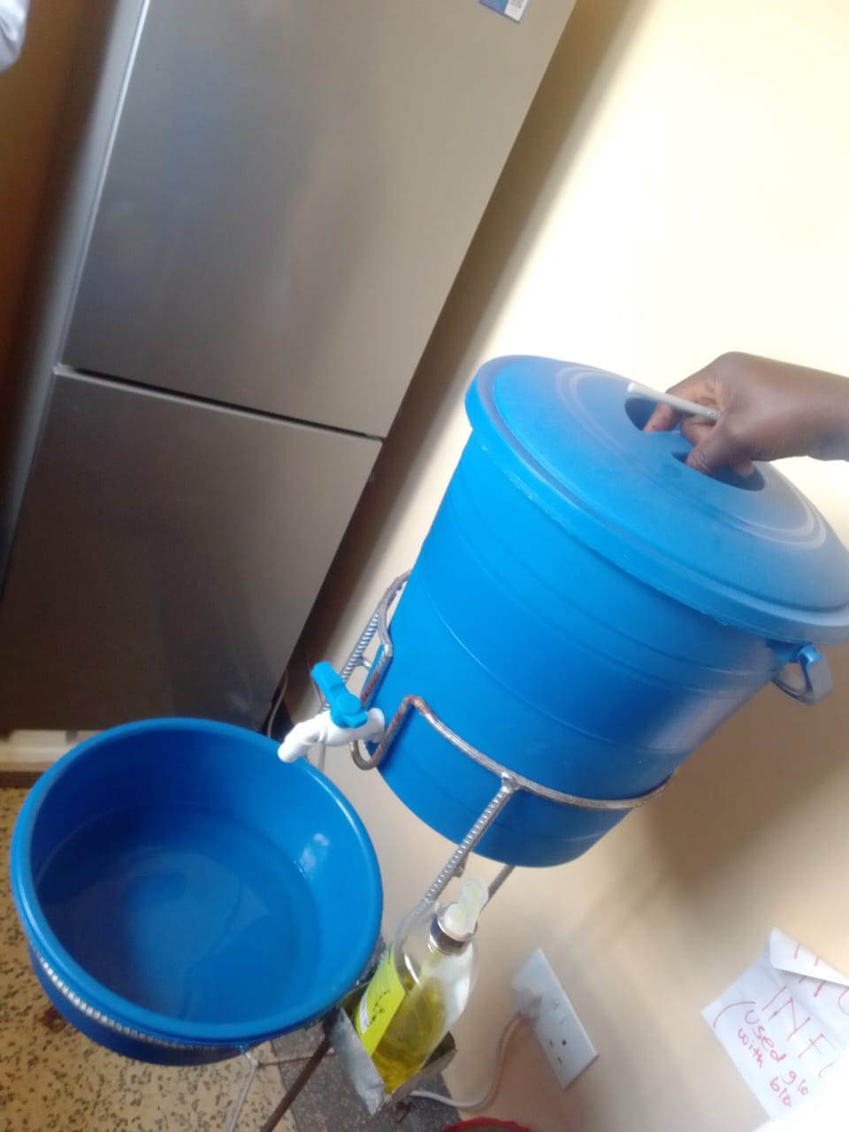
Microscope binocular | 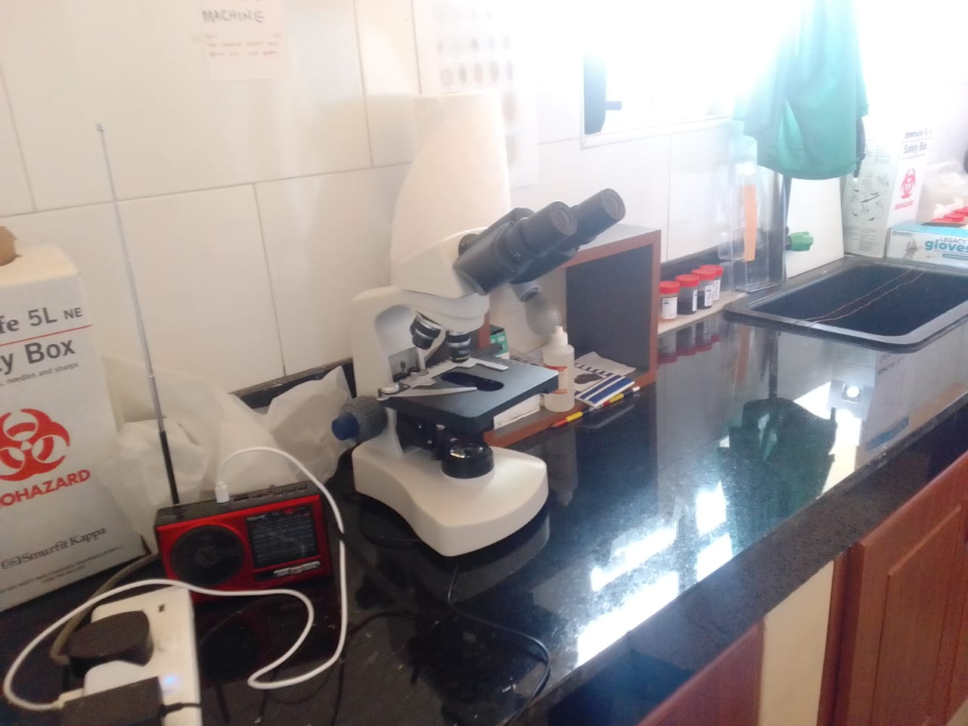
centrifuge | 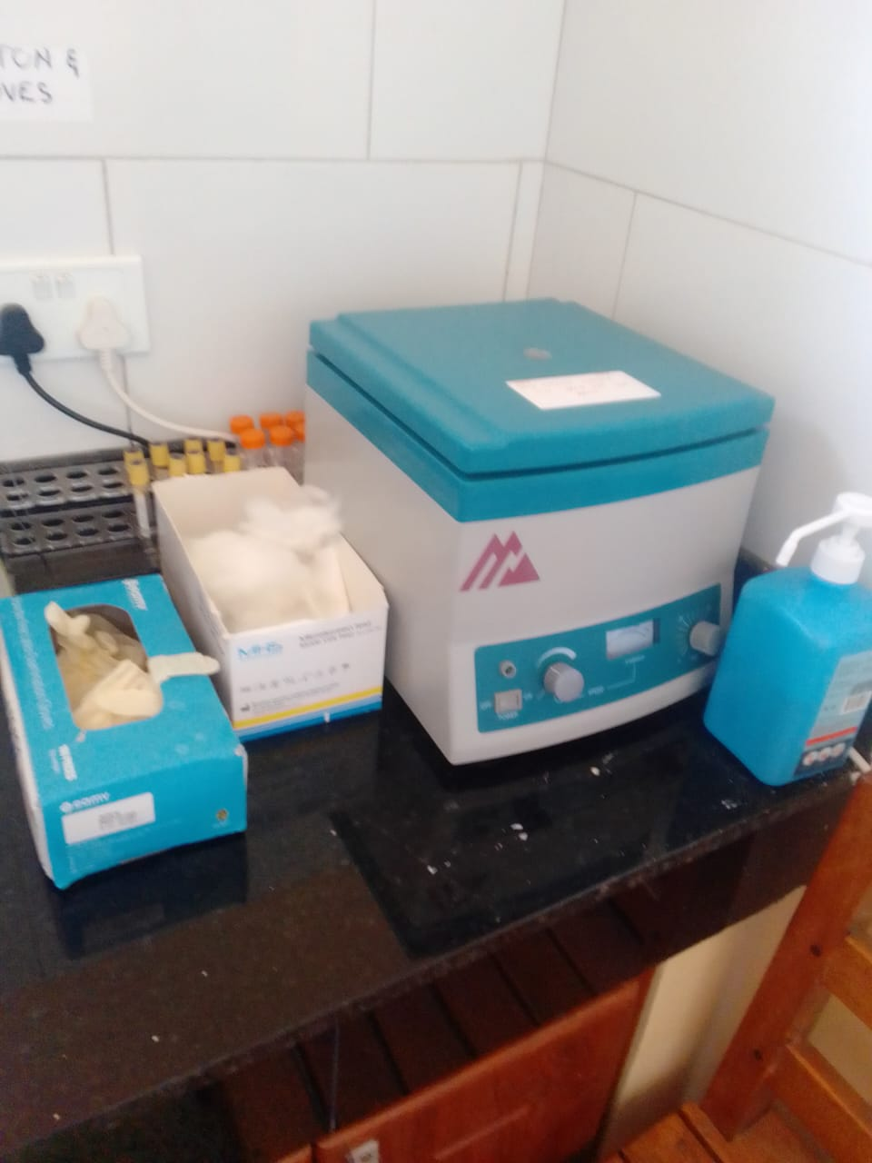
Instrument sets in the cupboard | 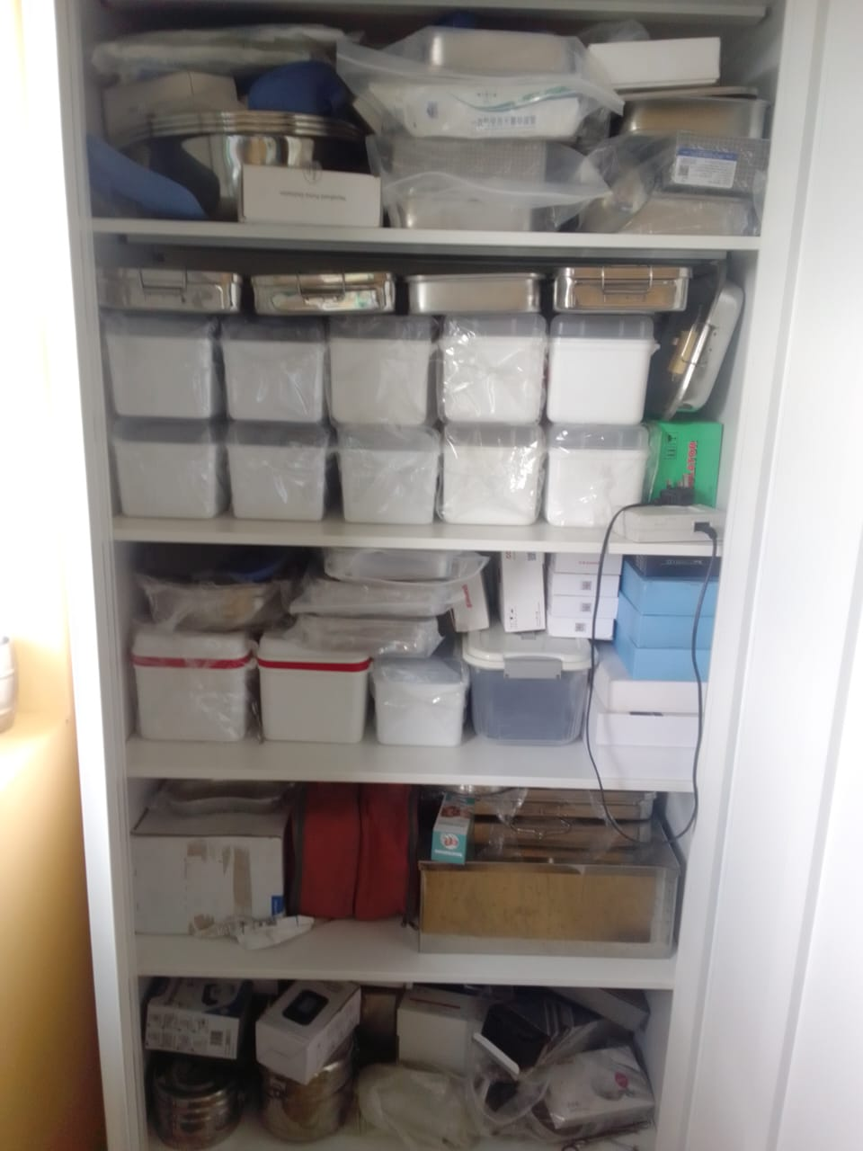
Examination couch, and patient screen | 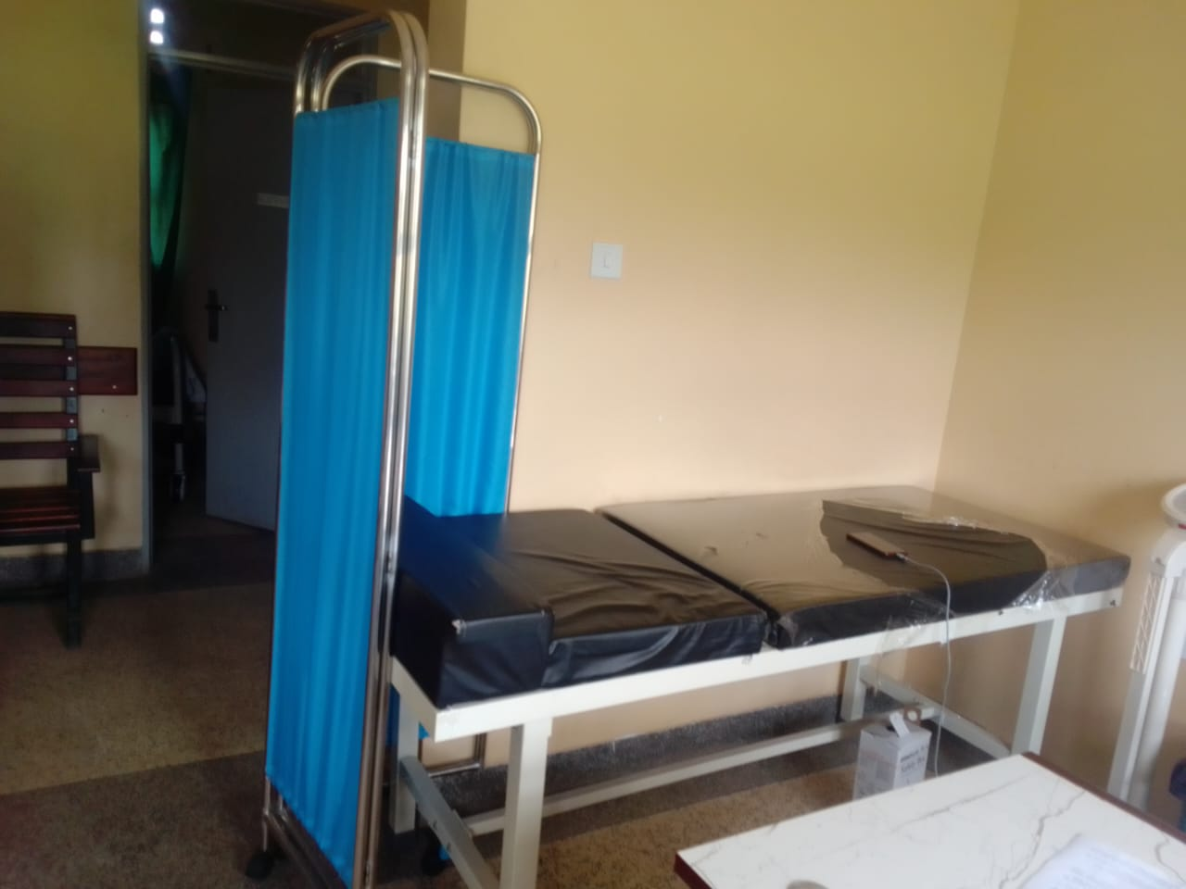
Delivery bed, hydraulic | 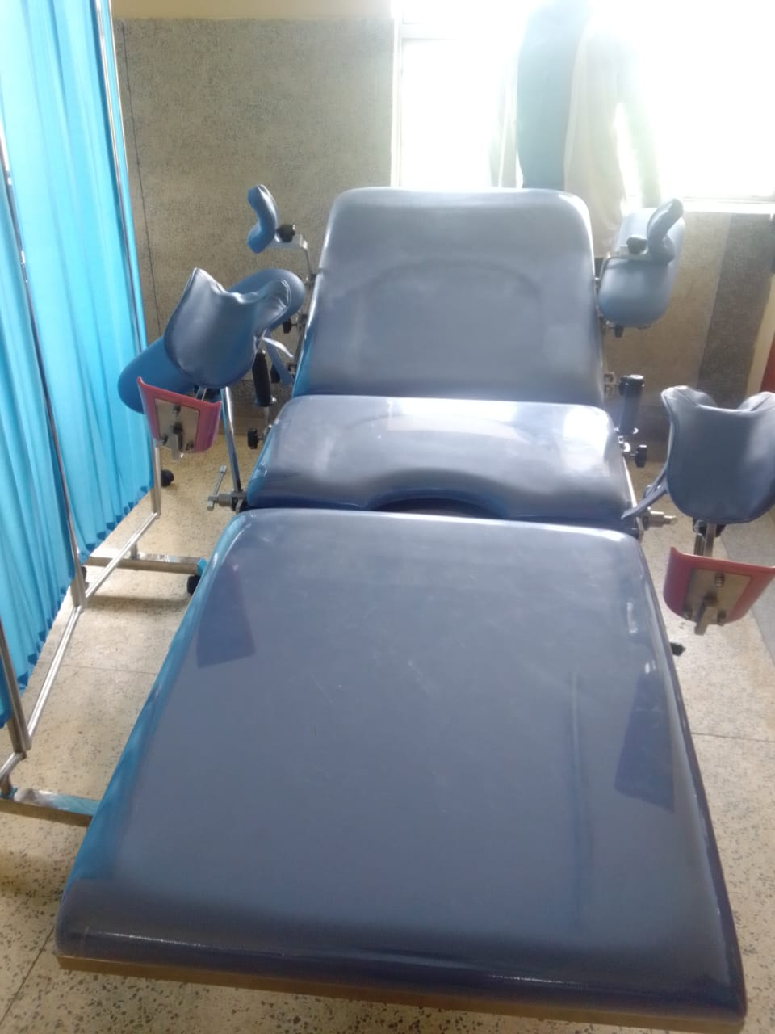
Delivery sets, MCH | 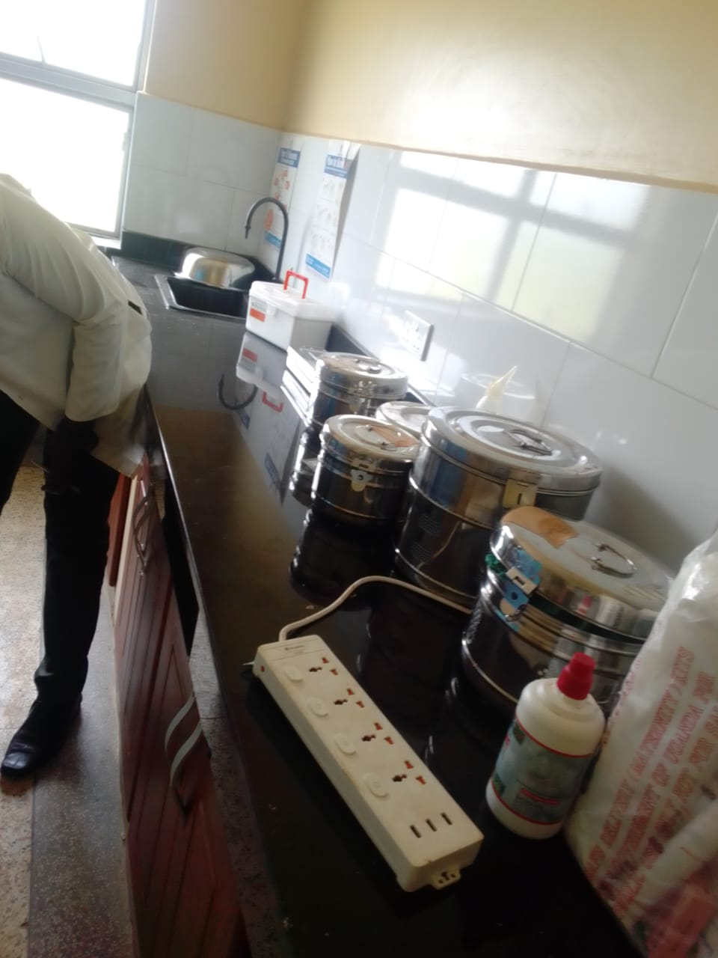
Examination light, LED | 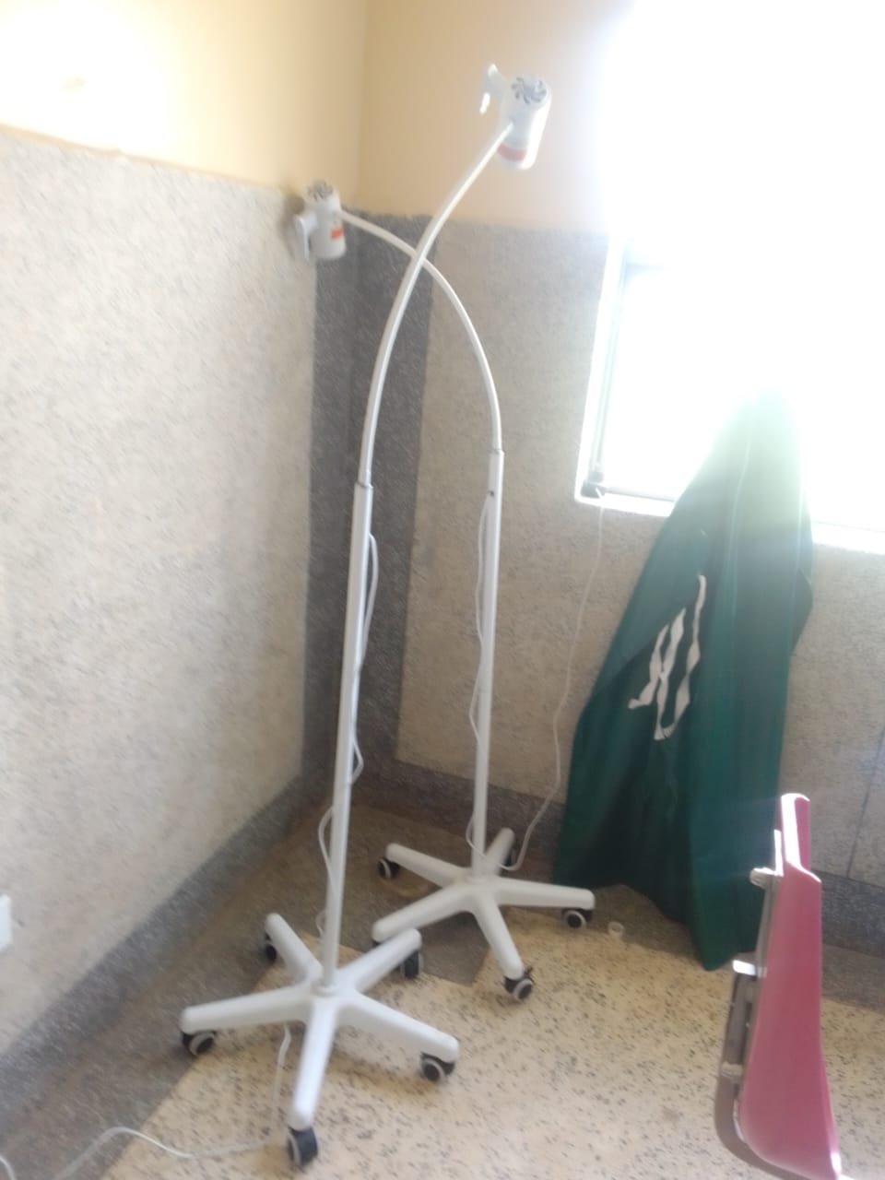
Oxygen concetrator | 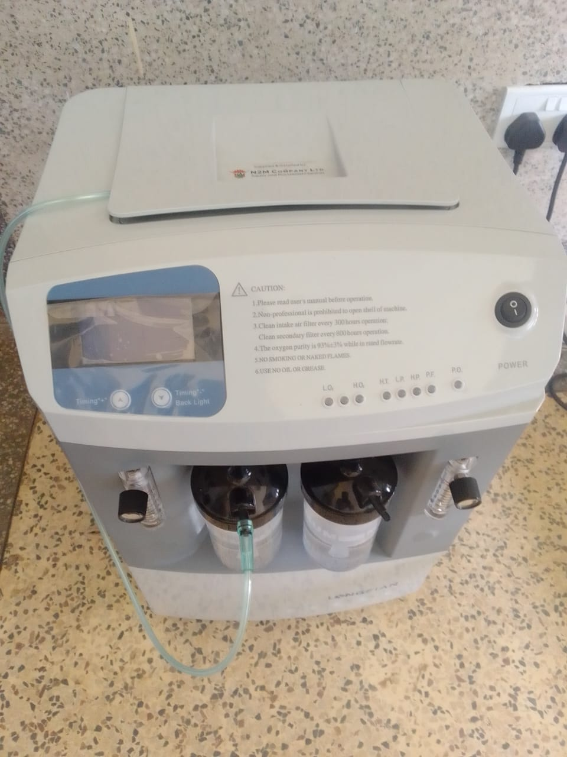
Tables, that are engraved | 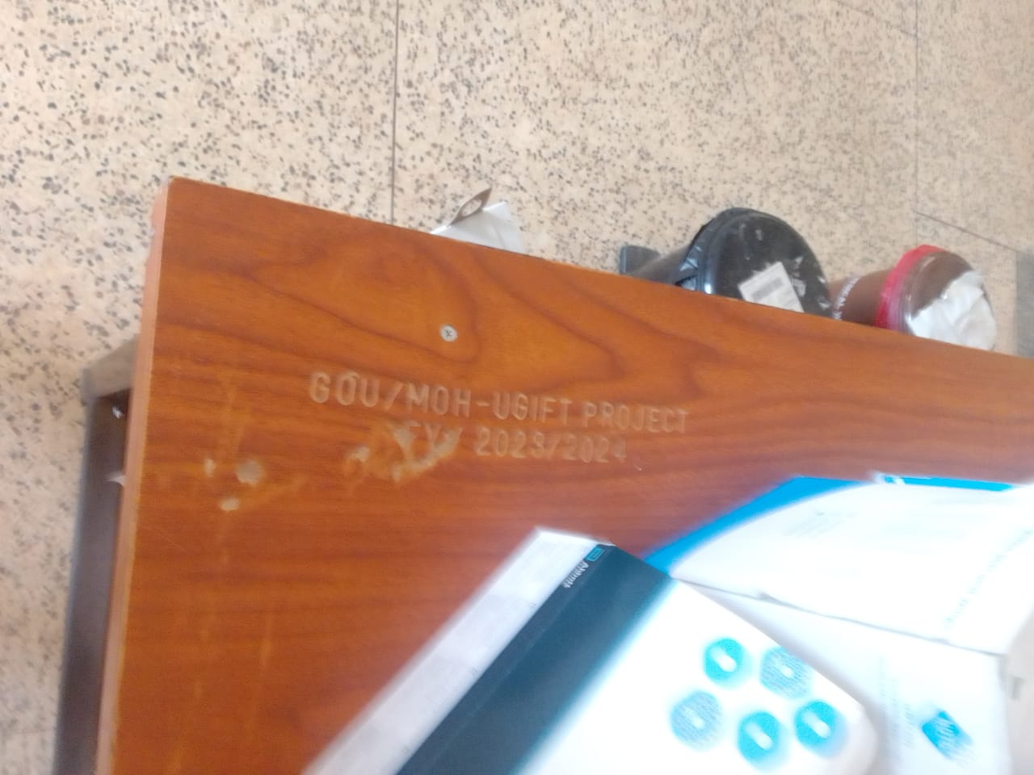  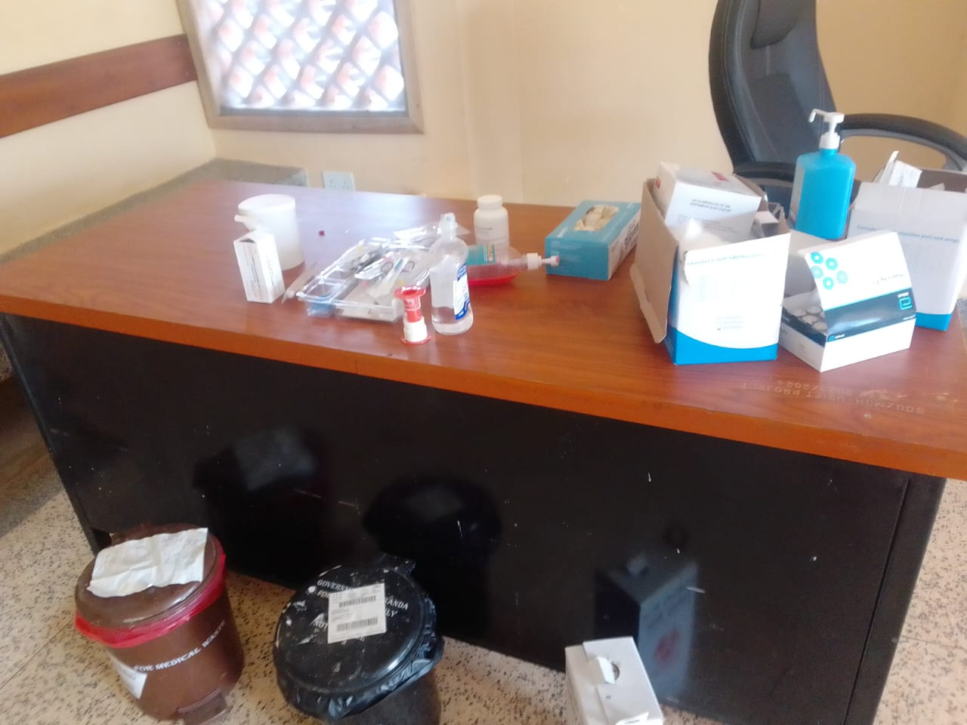
Sample of the benches that are engraved | 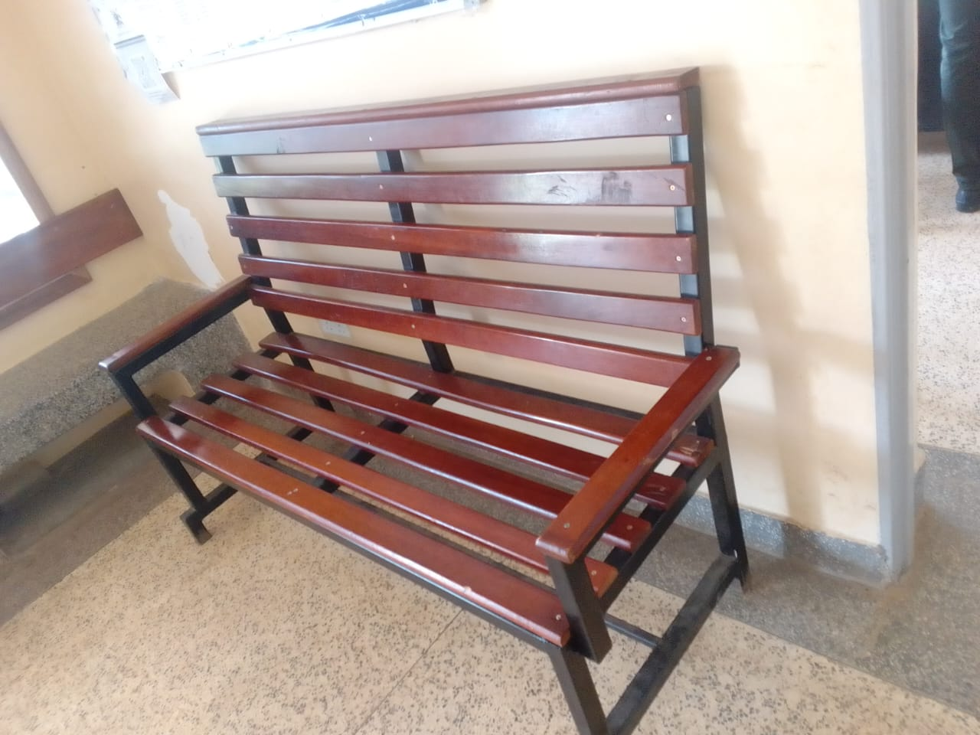  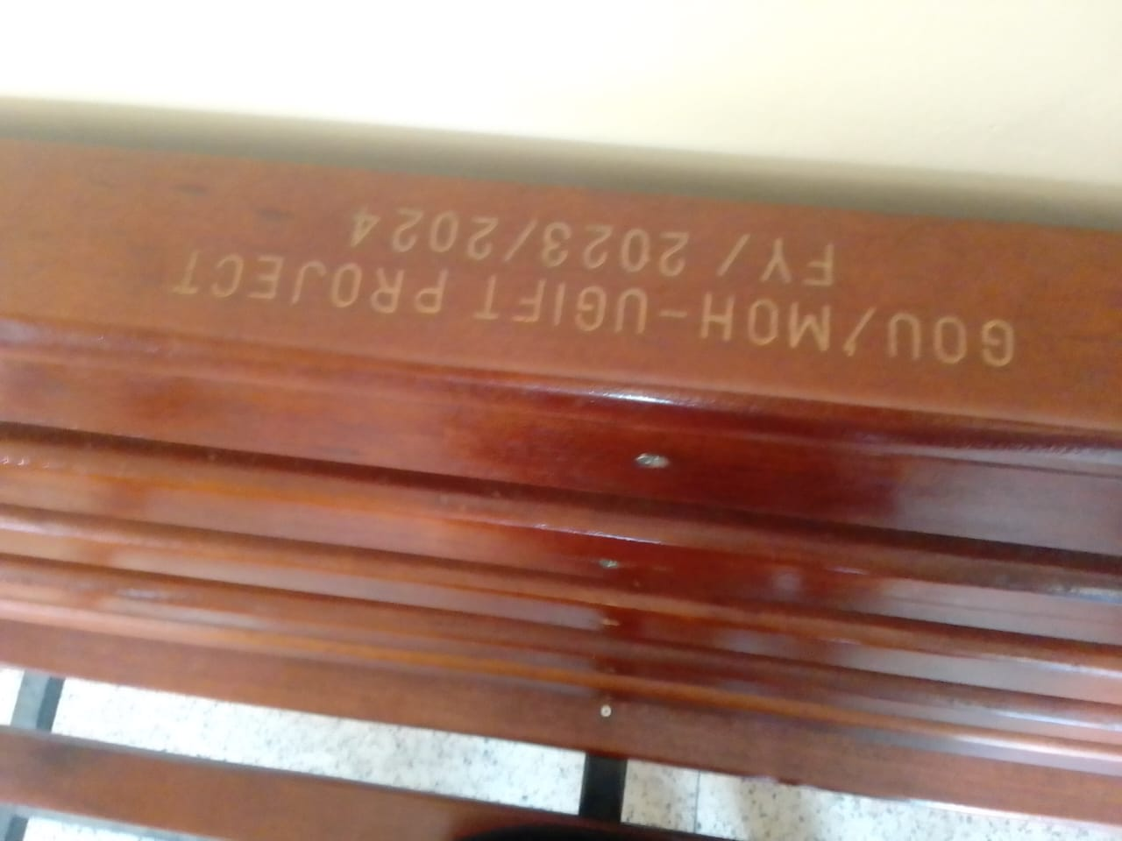
Cupboard with glass, still in its box | 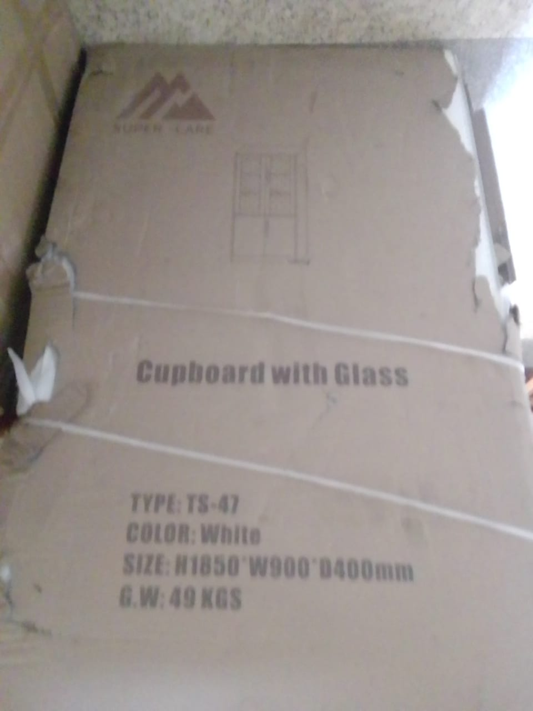
Weighing scale toddler, and other equipment packed in the store | 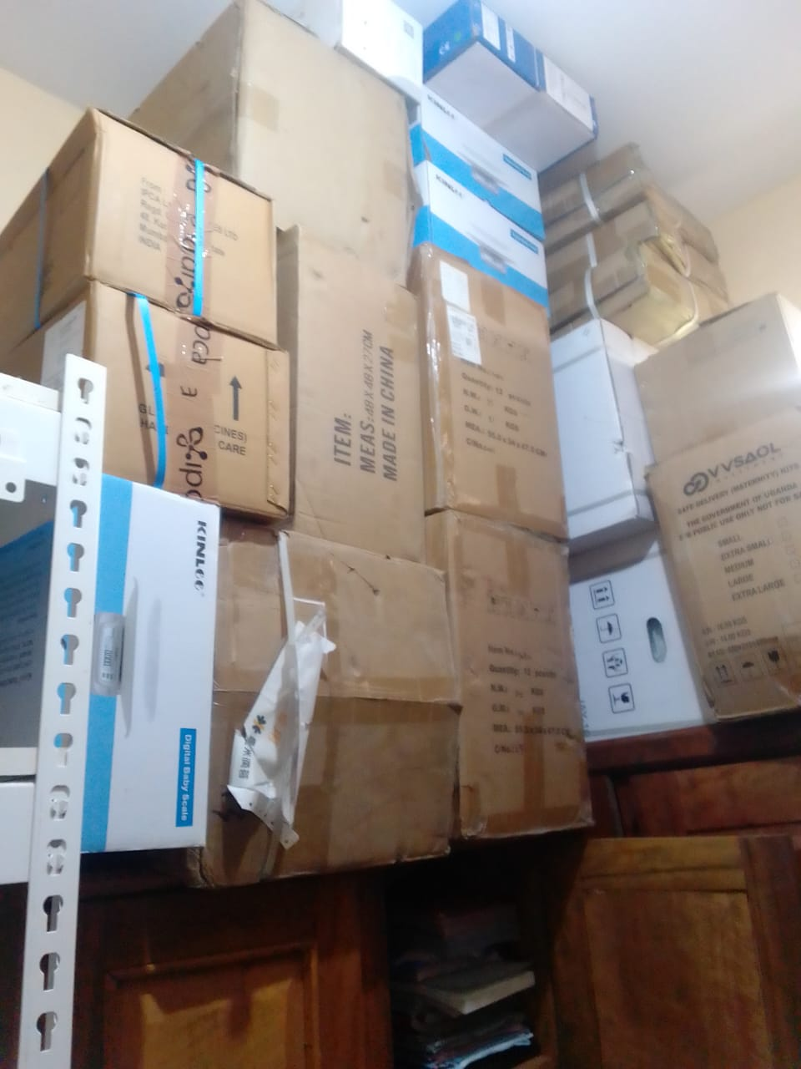
Sample of wighing scale, adult with a height meter | 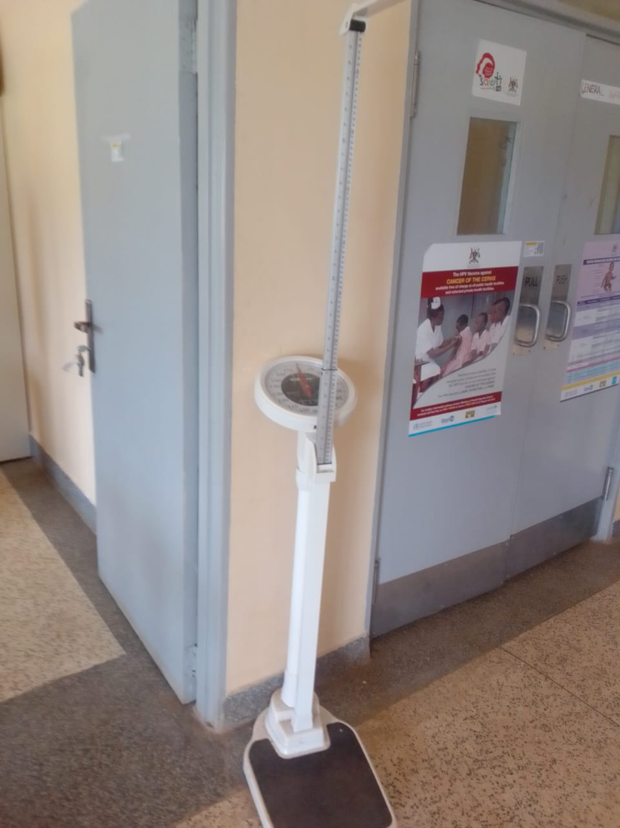
Height meter, with a stepping pallet | 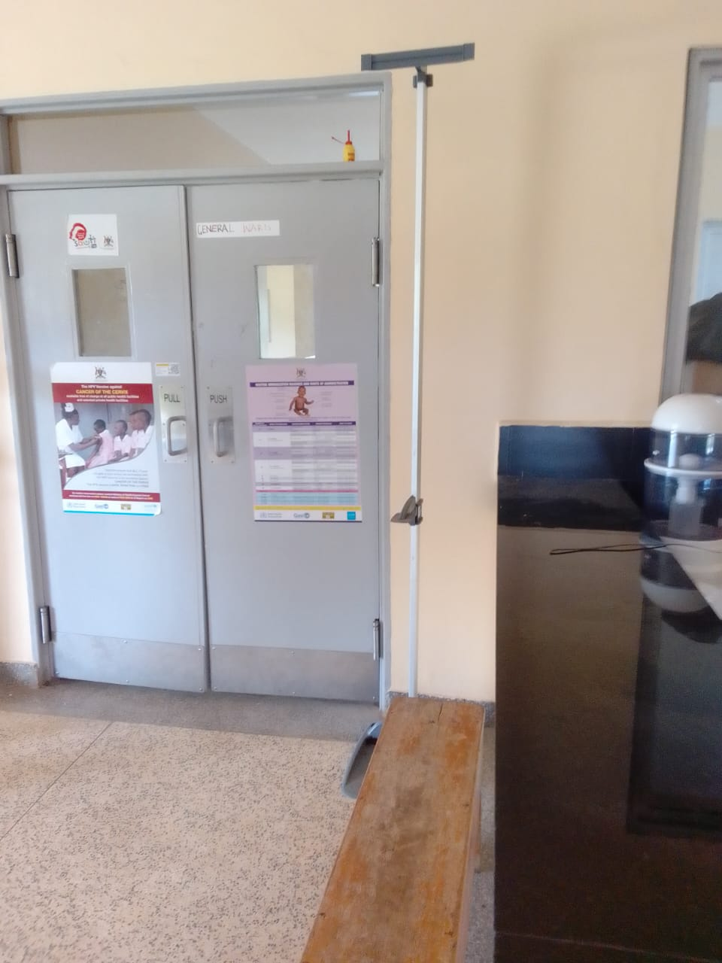
Sample of filling cabinet | 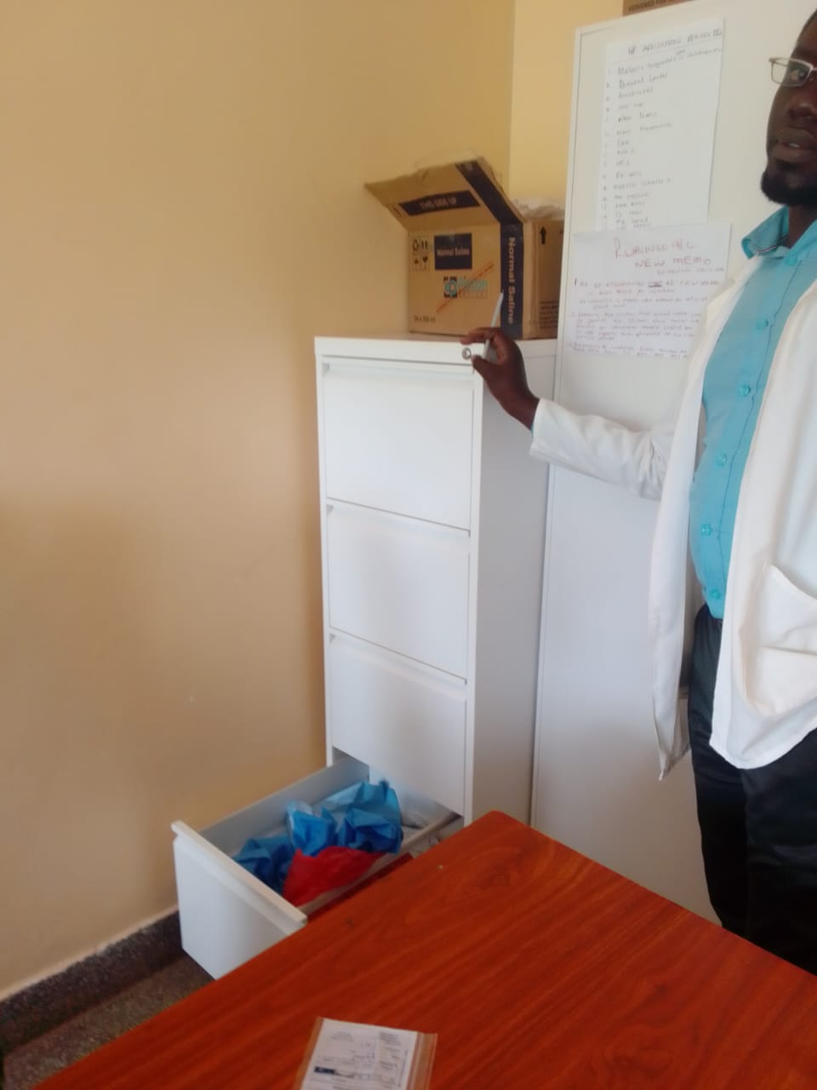
Cupboard metallic locable | 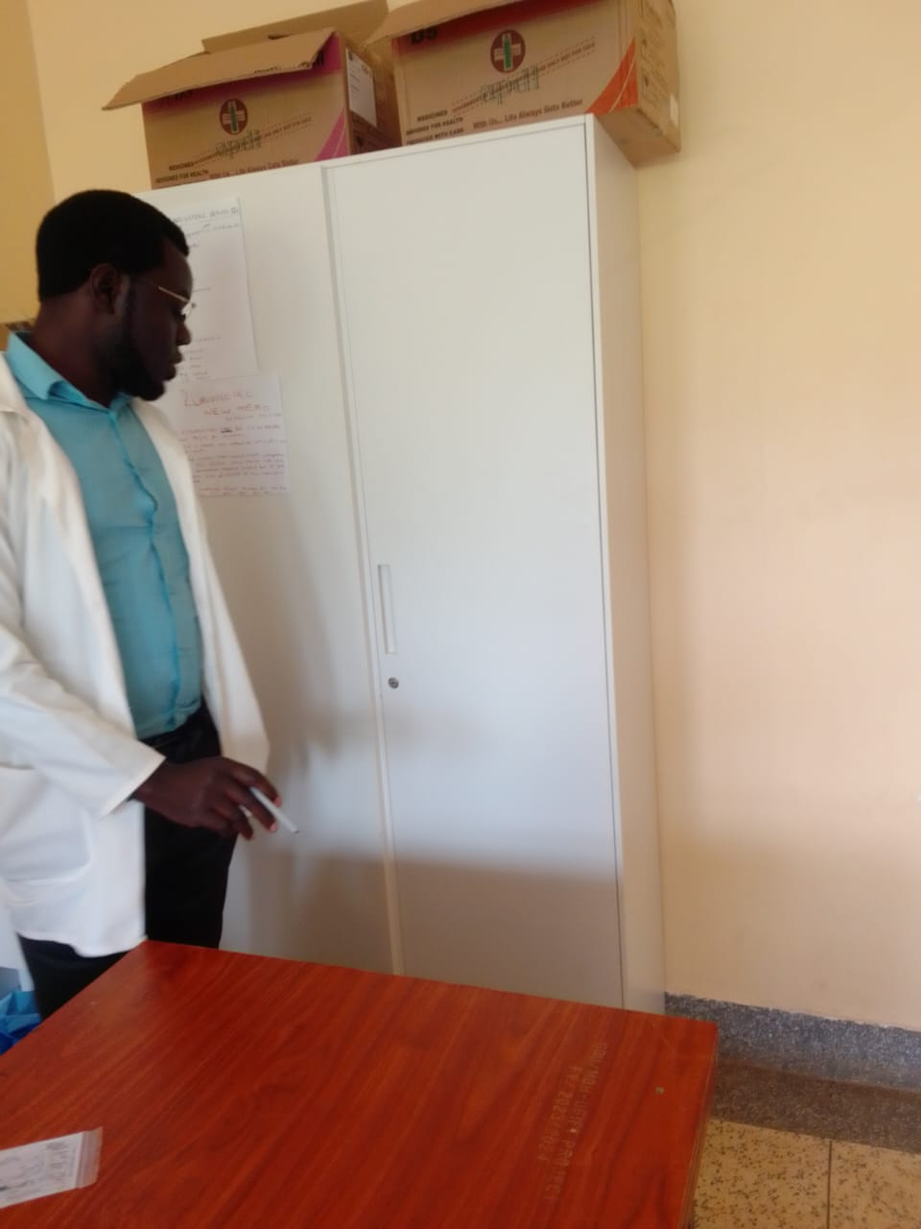
Sample of Stretcher, with drip stand | 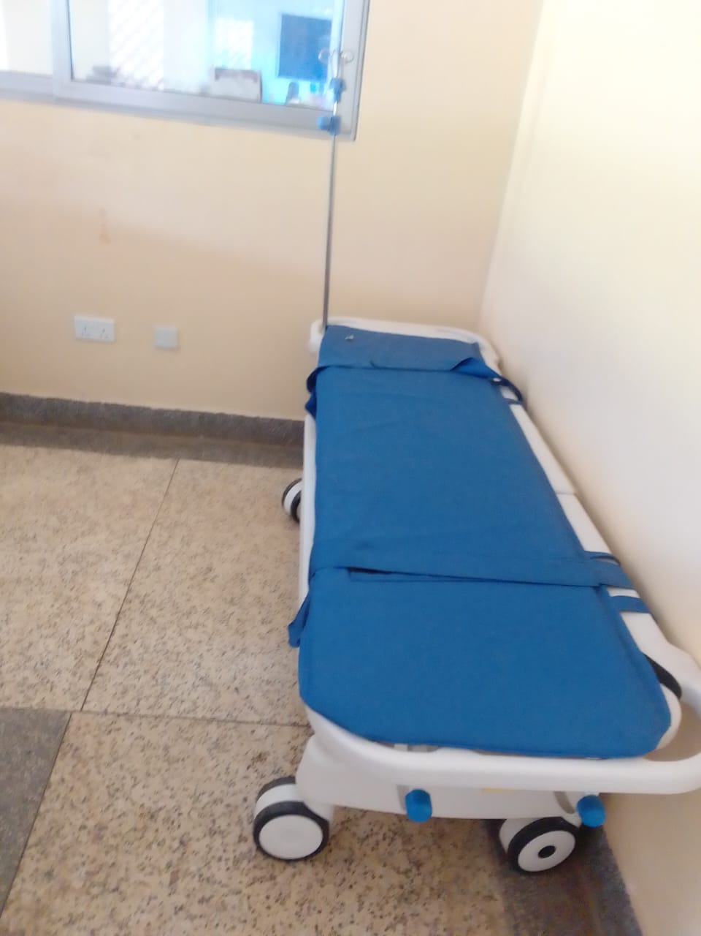
Sample of adult patient beds with drip stands | 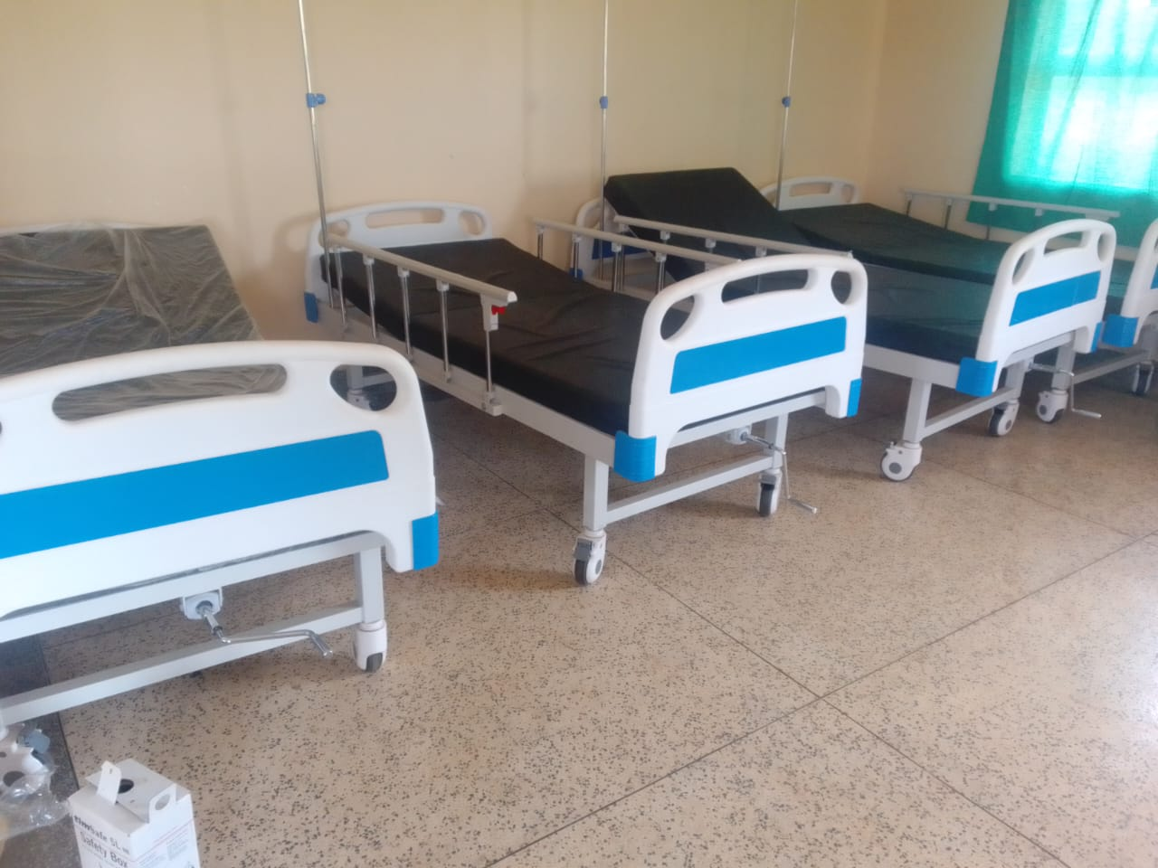
Sample of pedriatic beds with drip stands | 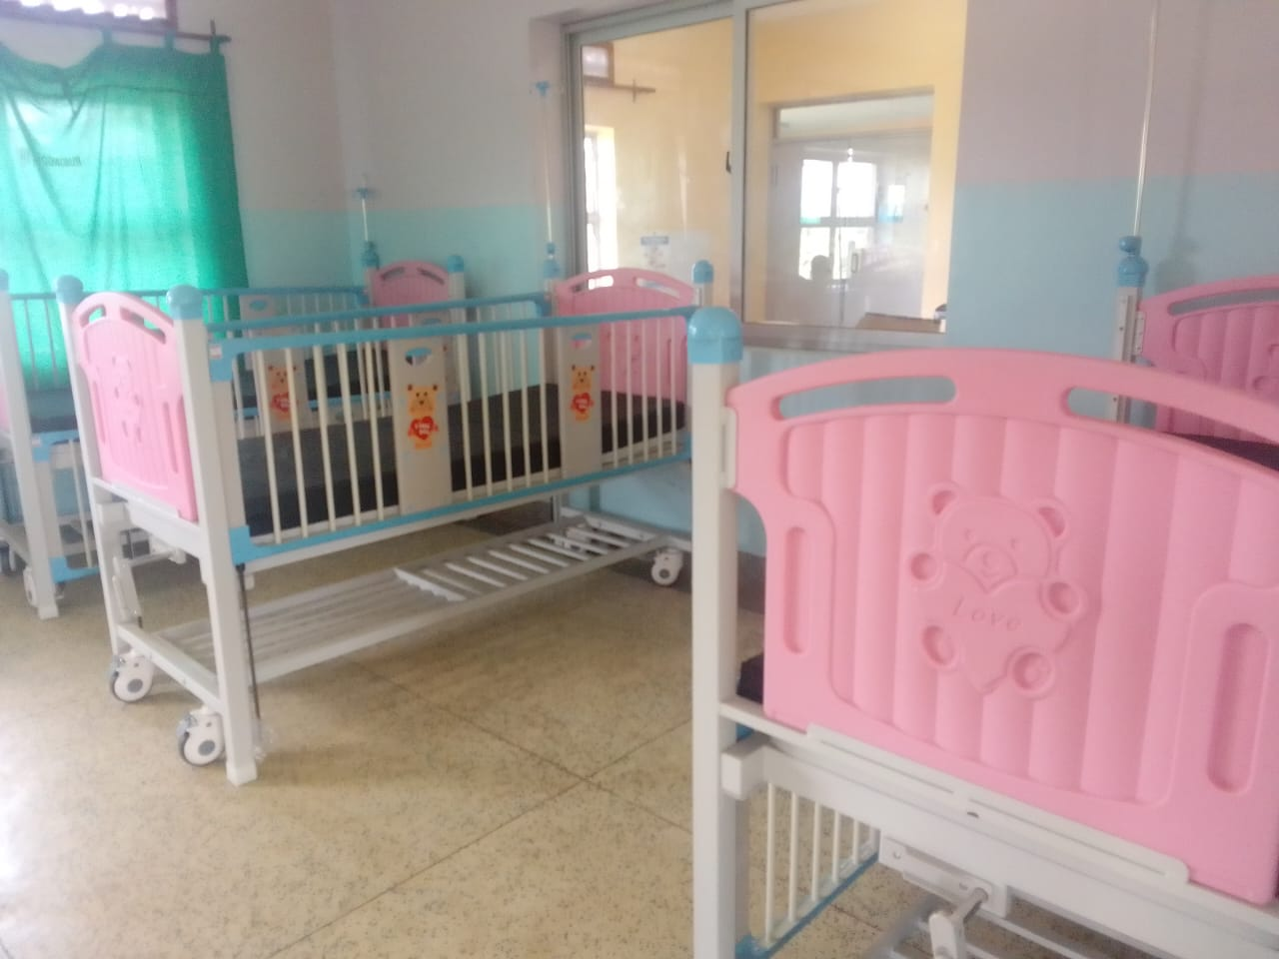
Sample of a wheelchair with a drip stand | 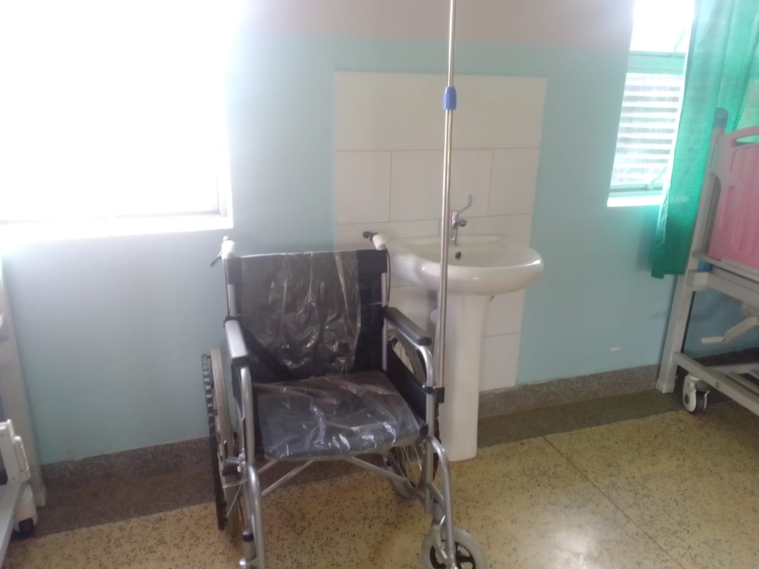
Newly supplied table from UGIFT With office chairs | 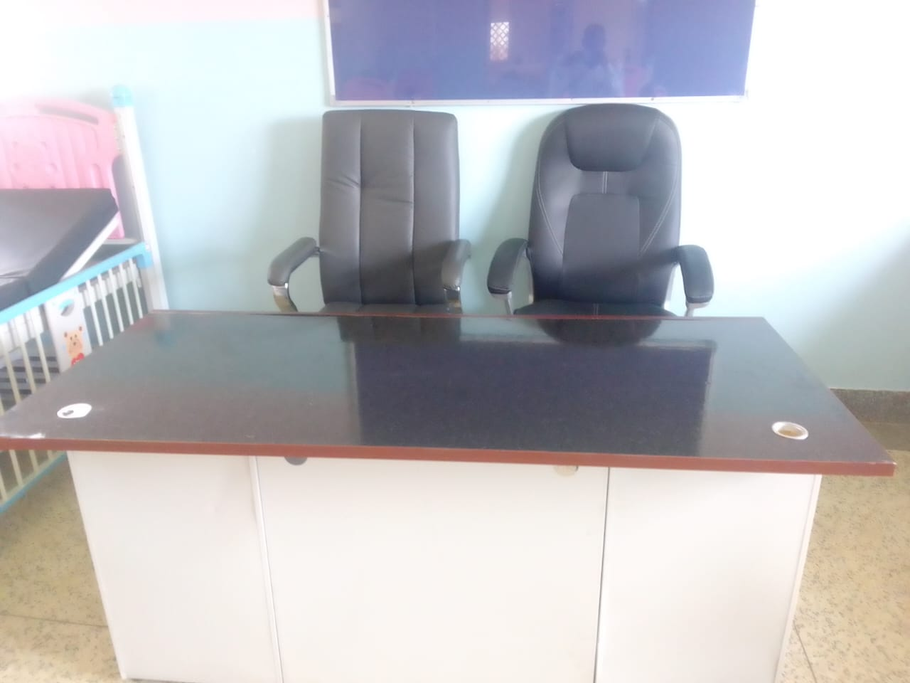
Kangaroo mother care chair still in the box | 